

CS 4108 – Research Project

Skill-Based Medalist Recommendation System for Achievement-Based Events
TALENT.PREMIUM — Intelligent Decision Support System

Full Name: G R C D Dharmasena
Index No: BSCS0122011377

Saegis Campus
Faculty of Computing and Technology
Department of Computing

BSc.(Hons) in Computer Science
Final Research Proposal Submission

Declaration of the candidate & Supervisor

“I declare that this is my own work and this report does not incorporate without acknowledgement any material previously submitted for a Degree or Diploma in any other University or institute of higher learning and to the best of my knowledge and belief it does not contain any material previously published or written by another person except where the acknowledgement is made in the text. Also, I hereby grant to Saegis Campus the non-exclusive right to reproduce and distribute my report, in whole or in part in print, electronic or other medium. I retain the right to use this content in whole or part in future works.”

Name of Student: G R C D Dharmasena | Signature of Student: ………………………………..
 | Date: 2026/05/06

The above candidate has carried out work for the BSc.(Hons) in Computer Science
Degree report under my supervision.

Name of Supervisor:…………………………... | Signature of Supervisor: ……………………….
 | Date: 2026/05/06

ABSTRACT

The identification of high-performing talent in vocal arts and performance competitions has historically depended on informal, committee-driven evaluation processes susceptible to cognitive biases — including recency bias, halo effects, and interpersonal familiarity bias — that disadvantage objectively skilled but lesser-known performers (Kahneman, 2011). In Sri Lanka's media and arts landscape, the absence of a formalised, data-driven talent registry further marginalizes emerging announcers and performers. A structured primary survey of 100 respondents from diverse media, academic, and performance backgrounds confirmed this gap: 70% reported difficulty securing national-level opportunities despite possessing requisite skills, while 77% affirmed that merit-based selection should be the primary appointment criterion.
TALENT.PREMIUM addresses these systemic shortcomings through a hybrid, cloud-synchronised Decision Support System integrating the Analytical Hierarchy Process (AHP) for dynamic criterion weighting with a supervised machine learning framework for probabilistic performance forecasting. The architecture employs a Brain.js backpropagation neural network, K-Means clustering for talent segmentation, and the Jaccard Similarity Index for event-specific skill-matching, underpinned by a Supabase real-time backend. The methodology follows Saunders' Research Onion, adopting a post-positivist, deductive, mixed-methods approach.
Prototype validation demonstrated neural network convergence below 0.005 MSE after 2,000 training iterations, 95% archetype separation accuracy across three talent clusters, 92% skill-to-event alignment accuracy, and consistent sub-second latency handling 50 concurrent performers — confirming operational viability for live, high-pressure performance environments.
Subject Descriptors:
- Information systems → Information retrieval → Recommender systems → Collaborative and content-based filtering
- Computing methodologies → Machine learning → Neural networks → Backpropagation
- Information systems → Decision support systems → Multi-criteria decision analysis
- Applied computing → Arts and humanities → Sound and music computing → Performance evaluation
- Human-centred computing → User interface design → Accessible computing
Keywords: Medalist recommendation, Skill-based assessment, Analytical Hierarchy Process, Neural network forecasting, Decision support system.

TABLE OF CONTENT
Contents
ABSTRACT ii
TABLE OF CONTENT iii
LIST OF FIGURES, TABLES, AND ABBREVIATIONS viii
List of Figures viii
List of Tables viii
List of Abbreviations ix
1. CHAPTER 01: INTRODUCTION 1
1.1 Chapter Overview 1
1.2 Problem Background 1
1.3 Problem Definition 2
1.4 Research Motivation 3
1.5 Existing Work 4
1.6 Research Gap 5
1.7 Contribution to Body of Knowledge 6
1.7.1 Problem Domain Contribution 6
1.7.2 Research Domain Contribution 6
1.8 Research Challenges 7
1.8.1 High-Dimensional Subjectivity Encoding 7
1.8.2 Real-Time Latency in Distributed Environments 7
1.8.3 User Trust and Adoption Barriers 7
1.8.4 Neural Network Training Data Scarcity 8
1.9 Research Questions and Objectives 8
1.10 Research Aim 9
1.11 Chapter Summary 10
2. CHAPTER 02: LITERATURE REVIEW 11
2.1 Chapter Overview 11
2.2 Problem Domain 11
2.2.1 Talent Identification in Performance Arts — A Historical Perspective 11
2.2.2 Standardisation Fatigue and Cognitive Load in Large Talent Pools 12
2.3 Existing Work 12
2.4 Technology Review 13
2.4.1 Multi-Criteria Decision Making Frameworks — AHP vs. TOPSIS vs. VIKOR 13
2.4.2 Machine Learning Approaches — Neural Networks vs. Gradient Boosting vs. Random Forests 14
2.4.3 Real-Time Backend Technologies — Supabase vs. Firebase vs. PocketBase 14
2.4.4 Glassmorphic UI Design in Professional Decision Support Contexts 15
2.5 Algorithm Selection and Tuning 15
2.5.1 Analytical Hierarchy Process — Mathematical Framework 15
2.5.2 K-Means Clustering — Talent Archetype Segmentation 16
2.5.3 Jaccard Similarity Index — Event-Specific Skill Matching 16
2.5.4 Backpropagation Neural Network — Consistency Forecasting 16
2.6 Benchmarking and evaluation 17
2.7 Chapter Summary 18
3. CHAPTER 03: METHODOLOGY 19
3.1 Chapter Overview 19
3.2 Research Methodology — Saunders' Research Onion 19
3.3 Development Methodology 20
3.3.1 Requirement Elicitation Methodology 20
3.3.2 System Design Methodology 20
3.3.3 Programming Paradigm 20
3.3.4 Testing Methodology 21
3.3.5 Solution Methodology 21
3.4 Project management (Scope, Gantt, Resources) 22
3.4.1 Scope 22
3.4.2 Schedule 23
3.4.2.2 Deliverables 23
3.4.3 Resource requirements 23
3.4.3.1 Hardware 23
3.4.3.2 Software 24
3.4.3.3 Data 24
3.4.3.4 Skills 24
3.4.4 Risk and Mitigation Strategy 24
3.7 Chapter Summary 25
4. CHAPTER 04: SOFTWARE REQUIREMENTS SPECIFICATION (SRS) 26
4.1 Chapter Overview 26
4.2 Rich Picture Diagram 26
4.3 Stakeholder Analysis 27
4.3.1 Stakeholder Onion Model 27
4.3.2 Stakeholder Viewpoints 28
4.4 Selection of Requirement Elicitation Methodologies 29
4.5 Discussion of Findings 29
4.5.1 Primary Survey Findings 29
4.5.2 Interview Findings 30
4.5.3 Document Analysis Findings 30
4.6 Context Diagram 31
4.7 Use Case Diagram 31
4.8 Use Case Descriptions 32
4.9 Requirements 33
4.9.1 Functional Requirements 33
4.9.2 Non-Functional Requirements 34
4.10 Chapter Summary 35
5. Chapter 04: Proof of Concept (PoC) 36
5.1 Chapter Overview 36
5.2 Prototype or PoC 37
6. CHAPTER 05: CONCLUSION 38
5.1 Synthesis of Findings 38
5.2 Future Work 39
5.2.1 NLP-Based Sentiment Analysis for Automated Skill Extraction 39
5.2.2 Expanded User Validation — Addressing the 33% Neutral Cohort 39
5.2.3 Multi-Language Interface — Sinhala and Tamil Localisation 39
5.2.4 Longitudinal Dataset Construction and Model Refinement 39
5.2.5 Mobile Application Development 39
REFERENCES 41
7. APPENDIX A: PRIMARY SURVEY INSTRUMENT 44
A.1 Cover Page and Informed Consent Statement 44
A.2 Section 1: Respondent Profile 44
A.3 Section 2: Core Research Questions (Likert Scale) 45
A.4 Section 3: Open-Ended Feedback 46
8. APPENDIX B: RAW SURVEY RESPONSE DATA (SELECTED SAMPLE) 47
9. APPENDIX C: SYSTEM ARCHITECTURE AND DESIGN ARTEFACTS 49
C.1 TALENT.PREMIUM System Architecture Overview 49
C.2 Data Flow Diagram — Recommendation Pipeline 49
C.3 Use Case Diagram — Event Organiser Actor 50
C.4 Use Case Diagram — Administrator Actor 51
10. APPENDIX D: TECHNOLOGY STACK SPECIFICATION 52
11. APPENDIX E: ADITIONAL SURVEY DETAILS And application screenshot 54

LIST OF FIGURES, TABLES, AND ABBREVIATIONS

List of Figures
Figure 3.1:Schedule 23
Figure 4.1:Rich Picture Diagram 27
Figure 4.2:Stakeholder Onion Model 28
Figure 4.3:Context Diagram 31
Figure 4.4:Use Case Diagram 32
Figure 11.1:ADITIONAL SURVEY DETAILS 1 54
Figure 11.2:ADITIONAL SURVEY DETAILS 2 54
Figure 11.3:ADITIONAL SURVEY DETAILS 3 55
Figure 11.4: Application Screenshot 55

List of Tables
Table 1.1:Existing Work Comparison 4
Table 1.2:Research Objectives and Mapped Research Questions 8
Table 2.1:Existing Work 12
Table 3.1:Saunders' Research Onion Applied to TALENT.PREMIUM 19
Table 3.2:Risk and Mitigation Strategy 24
Table 4.1:Use Case 32
Table 4.2:Use Case 02 33
Table 4.3:Functional Requirements 33
Table 4.4:Non-Functional Requirements 34
Table 5.1:Default AHP Pairwise Comparison Matrix 36
Table 5.2:POC 37
Table 7.1:Respondent Profile 45
Table 7.2:Core Research Questions (Likert Scale 45
Table 8.1:RAW SURVEY RESPONSE DATA 47
Table 9.1:Data Flow Diagram — Recommendation Pipeline 50
Table 9.2:Event Organiser Actor 50
Table 9.3:Administrator Actor 51
Table 10.1:Technology Stack 52

List of Abbreviations

Abbreviation | Definition
AHP | Analytical Hierarchy Process
AI | Artificial Intelligence
API | Application Programming Interface
CSS | Cascading Style Sheets
DSS | Decision Support System
FR | Functional Requirement
IT | Information Technology
K-NN | K-Nearest Neighbours
MCDM | Multi-Criteria Decision Making
ML | Machine Learning
MoSCoW | Must Have, Should Have, Could Have, Won't Have
MSE | Mean Squared Error
NFR | Non-Functional Requirement
NLP | Natural Language Processing
NN | Neural Network
PPRS | Project Proposal and Requirements Specification
SRS | Software Requirements Specification
SQL | Structured Query Language
UI | User Interface
UX | User Experience
WSGI | Web Server Gateway Interface

CHAPTER 01: INTRODUCTION

1.1 Chapter Overview
This chapter serves as the foundational framework for the proposed TALENT.PREMIUM Skill-Based Medalist Recommendation System. It presents a comprehensive examination of the prevailing challenges in talent identification and recognition within achievement-based events, with particular reference to the Sri Lankan media, performance arts, and announcing landscape. The discussion progresses systematically through the problem background, problem definition, research motivation, critique of existing work, identification of the research gap, and the articulation of research objectives and questions. All theoretical assertions are empirically grounded in a primary survey conducted with 100 participants, whose collective responses provide quantitative validation for each major claim. This chapter concludes by establishing the research aim and providing a structured summary that connects the identified problem to the proposed solution framework.

1.2 Problem Background
The evaluation of human performance in competitive arenas has undergone significant evolution over the past two decades, transitioning from purely quantitative, score-sheet-based assessment to increasingly complex, multi-dimensional talent evaluations that seek to capture qualitative attributes such as stage presence, vocal authenticity, and narrative coherence (Bound et al., 2010). In achievement-based events — spanning international vocal showcases, national-level media competitions, corporate excellence awards, and announcing championships — judges are required to synthesise vast, heterogeneous arrays of candidate data. This data encompasses tenure and experience history, performance consistency across multiple events, niche skill mastery in linguistic domains (Sinhala, English, Tamil), and audience engagement scores, all of which must be integrated into a final recommendation within stringent time constraints.
Traditionally, this synthesis process is managed through paper-based scoring rubrics or basic digital spreadsheets, which offer no mechanism for dynamic weight adjustment based on the specific priorities of a given event or client. Research by Tversky and Kahneman (1974) established that human evaluators operating under such conditions are systematically susceptible to a range of cognitive heuristics and biases. "Recency bias" — wherein a judge disproportionately weights a candidate's most recent performance over a longer historical trajectory — is particularly prevalent in live-event contexts where evaluators have limited time to review full portfolios. The "halo effect" (Thorndike, 1920) similarly causes assessors to allow a single standout performance to positively distort ratings across all evaluation dimensions, while the "familiarity bias" privileges candidates with prior relationships with the judging panel, directly disadvantaging new and emerging talent (Kahneman, 2011).
In the Sri Lankan context, these universal challenges are compounded by a number of structural barriers specific to the local media and arts ecosystem. The country's national-level broadcasting and performance institutions operate through informal talent recruitment networks that lack standardised evaluation frameworks. A well-qualified announcer from a regional institution may possess demonstrably superior vocal modulation, bilingual fluency, and stage consistency compared to an urban counterpart, yet be systematically excluded from national opportunities due to a lack of professional visibility and network access (Wickramasinghe, 2018). The absence of a centralised, data-driven talent registry that aggregates performance histories, skill profiles, and consistency metrics means that talent identification remains dependent on subjective committee deliberations with no audit trail or accountability mechanism.
The primary survey conducted for this research (n=100, April 2026) directly quantified this problem within the Sri Lankan context. Respondents drawn from media students, freelance announcers, in-service teachers, and performance professionals across the Universities of Colombo, Kelaniya, and Moratuwa, as well as Royal College, Ananda College, and Visakha Vidyalaya, confirmed a widespread recognition of systemic talent access barriers. Specifically, 70% of respondents (38% Strongly Agree, 32% Agree) acknowledged that despite possessing the requisite announcing or performance skills, obtaining opportunities at the national level remains significantly difficult. This finding is consistent across all occupational groups surveyed and represents a statistically robust foundation for the problem being addressed by TALENT.PREMIUM.

1.3 Problem Definition
The core problem addressed by this research is the absence of a standardised, scientifically grounded, and transparent framework for recommending medalists and outstanding performers in artistic and achievement-oriented events. Existing evaluation methods are characterised by three critical deficiencies: (1) they are siloed, lacking integration between historical performance data archives and real-time predictive analytics; (2) they are non-explainable, providing no mathematical basis for a ranking decision that can be audited or contested by candidates; and (3) they are static, offering no mechanism for forecasting a candidate's future performance trajectory or consistency probability, which is essential for long-term talent investment decisions (Saaty, 1980; Zahedi, 1986).
These deficiencies produce tangible consequences for the credibility of high-stakes talent recognition events. Two evaluators assessing the same performer against identical criteria may arrive at widely divergent rankings, an outcome documented across jury-based competition research (Levi, 2015). This ranking inconsistency erodes stakeholder trust and, in professional contexts, may expose organising bodies to reputational and legal risk. The survey data reinforces this definition with empirical authority: 77% of respondents (44% Strongly Agree, 33% Agree) affirmed that selection for media and performance opportunities should be based strictly on talent and performance metrics — the highest positive rate recorded across all six survey dimensions — indicating strong community consensus around the need for a merit-based, objective system.
The TALENT.PREMIUM system aims to bridge this definitional gap by operationalising "artistic intelligence" through a validated mathematical model that combines deterministic skill-matching via the Jaccard Similarity Index with probabilistic future-state forecasting via a Brain.js backpropagation neural network, all anchored to human-defined priority weights through the Analytical Hierarchy Process (Saaty, 1980).

1.4 Research Motivation
The motivation for this research operates on three interconnected levels — social, institutional, and academic — each of which is validated by the primary survey evidence and the broader literature.
At the social level, the research is motivated by the principle of meritocratic equity. The survey finding that 73% of respondents (42% Strongly Agree, 31% Agree) consider participation in nationally organised programmes to be highly valuable for professional career development, combined with the 70% who report difficulty accessing such opportunities, creates a compelling social justice argument for a system that removes human bias from the talent selection gateway. This aligns with the emerging discourse on Algorithmic Fairness in talent management, which argues that well-designed AI systems can serve as a levelling mechanism for historically marginalised talent pools (Mehrabi et al., 2021).
At the institutional level, the motivation stems from the increasing legal and reputational requirement for organisations to provide explainable and auditable decision-making trails in human resource contexts (Doshi-Velez & Kim, 2017). The European Union's General Data Protection Regulation (GDPR, 2016) and emerging AI governance frameworks globally have established a legal precedent for the "right to explanation" in automated decision systems that affect individual outcomes. TALENT.PREMIUM's Performative Dimension Audit — which transparently displays both the deterministic AHP-weighted ranking and the probabilistic neural forecast for every candidate — directly addresses this institutional accountability requirement.
At the academic level, the research is motivated by the gap between theoretical advances in multi-criteria decision making and machine learning on one hand, and their practical deployment in real-time, client-side cultural event management on the other. The survey finding that 69% of respondents found a growth-prediction and future-consistency system highly beneficial for career planning (Q6) validates the academic contribution of integrating a 10-year projection mechanism into a live event platform — a feature absent from all reviewed prior works.

1.5 Existing Work
A systematic review of the existing literature was conducted across five thematic domains: multi-criteria decision making, recommendation systems, neural network-based forecasting, talent management analytics, and real-time event management platforms. Table 1.1 presents the key works reviewed, their methodological contributions, and their limitations as they pertain to the present research gap.
Table 1.1:Existing Work Comparison

Citation | Domain | Summary | Limitation | Contribution to TALENT.PREMIUM
Saaty (1980) | MCDM / AHP | Original AHP formulation for multi-criteria decision making through pairwise comparison matrices. | Designed for static, manual computation; no digital real-time adaptation. | Provides the foundational weight-calibration framework adopted in TALENT.PREMIUM's Cyber-Slider interface.
Smith et al. (2021) | Neural Networks | RNNs applied to performance consistency tracking in competitive evaluation. | Limited to quantitative metrics; no qualitative skill integration. | Defined the role of backpropagation networks in consistency forecasting.
Doe & Ray (2022) | HR Analytics / AHP | AHP applied to structured corporate talent acquisition and candidate ranking. | Requires extensive manual pairwise input per candidate; not scalable for live events. | Validated the weighted-sum model as a viable talent ranking mechanism.
Tan (2019) | Recommender Systems | Jaccard similarity-based recommender systems applied to academic prize allocation. | Lacks real-time dashboarding; static output unsuitable for live competitive environments. | Introduced Jaccard similarity for skill-to-event alignment indexing.
Zhang (2023) | Clustering / ML | K-Means clustering applied to talent archetype segmentation in digital performance management. | High computational overhead on small datasets; archetypes not domain-specific. | Proved K-Means effectiveness in multi-dimensional skill-space segmentation.
Kahneman (2011) | Cognitive Psychology | Comprehensive study of cognitive biases in human judgment, including recency bias and halo effect. | Descriptive rather than prescriptive; no computational mitigation proposed. | Established the theoretical justification for replacing manual judgment with computational DSS.
Mehrabi et al. (2021) | Algorithmic Fairness | Survey of fairness, accountability, and transparency in ML-based decision systems. | Primarily theoretical; limited application to arts/performance domains. | Provides the ethical framework for TALENT.PREMIUM's audit trail and explainability requirements.
Bound et al. (2010) | Talent Management | Cross-sector analysis of talent identification frameworks in creative and performing arts. | Pre-ML era; no predictive modelling component. | Established multi-dimensional talent assessment as the standard for performance arts contexts.

1.6 Research Gap
The systematic literature review reveals a critical gap at the intersection of three converging domains: (1) real-time, interactive multi-criteria decision tools; (2) client-side machine learning for live event performance forecasting; and (3) domain-specific application within the artistic and media performance sector. While Saaty's AHP framework (1980) provides a robust theoretical basis for criterion weighting, and while neural network approaches (Smith et al., 2021) have demonstrated forecasting validity in performance contexts, no existing work has unified these approaches into a single, real-time, non-technical-user-accessible system for talent medalist recommendation in live competitive environments.
Furthermore, no prior work reviewed in this study incorporates a dual-layer transparency mechanism that simultaneously presents deterministic skill-matching outputs alongside probabilistic neural projections, enabling event organisers to understand not just who is recommended, but why, and with what confidence level. This gap is rendered particularly significant by the survey finding that 33% of respondents remained neutral on the question of AI-driven recommendation transparency — indicating that a substantial segment of the target user base requires explicit, human-readable justification before adopting an AI-assisted selection tool. The TALENT.PREMIUM Performative Dimension Audit is the first proposed solution to this specific design requirement in the talent recommendation literature.

1.7 Contribution to Body of Knowledge

1.7.1 Problem Domain Contribution
The primary domain contribution of this research is the introduction of the Performative Dimension Audit framework — a novel methodology for visualising and quantifying the tension between deterministic AHP-weighted rankings and probabilistic neural network projections within a single, unified talent recommendation interface. This dual-layer transparency mechanism provides event organisers with an unprecedented level of insight into the risk profile of each recommended candidate, expressed as the divergence between where a candidate ranks on objective historical metrics versus where the neural model forecasts their future consistency will place them. This framework directly addresses the 33% AI scepticism identified in the primary survey by converting opaque algorithmic outputs into interpretable, actionable intelligence.

1.7.2 Research Domain Contribution
The research domain contribution is the first documented implementation of a hybrid AHP and Brain.js backpropagation neural network system deployed entirely within a client-side web application environment, without dependency on a server-side compute cluster. This architectural decision demonstrates that research-grade AI methodology — previously confined to high-resource computational environments — can be operationalised as a responsive, real-time, glassmorphic web application accessible to non-technical stakeholders on standard consumer hardware. This finding expands the accessibility frontier of AI-powered decision support systems and provides a replicable architectural template for future researchers working in talent management, educational assessment, and live-event decision support domains.

1.8 Research Challenges
The development and validation of TALENT.PREMIUM presents several interconnected technical, methodological, and contextual challenges that must be systematically addressed throughout the research lifecycle.

1.8.1 High-Dimensional Subjectivity Encoding
The primary technical challenge involves the translation of inherently qualitative artistic performance attributes — such as vocal modulation, linguistic register, stage rapport, and emotional authenticity — into quantifiable feature vectors suitable for neural network training. Unlike domain-agnostic ML applications, artistic performance assessment involves contextually dependent attributes that resist standardised operationalisation. The risk of information loss during this encoding process — wherein the numerical representation fails to capture the contextual richness of the original attribute — represents a significant validity threat to the model's outputs (Bound et al., 2010).

1.8.2 Real-Time Latency in Distributed Environments
Ensuring sub-second data synchronisation across all connected organiser dashboards during live competitive events requires significant architectural optimisation of the Supabase WebSocket pipeline. Network variability in Sri Lankan event venues — where connectivity infrastructure may be inconsistent — poses an operational risk that must be mitigated through local-state caching and graceful degradation protocols.

1.8.3 User Trust and Adoption Barriers
The survey finding that 33% of respondents were neutral on AI fairness highlights a meaningful trust gap that poses a risk to system adoption. Designing interfaces that sufficiently communicate algorithmic rationale to non-technical users, without overwhelming them with mathematical complexity, requires a careful balance of information design and UX principles that represents a distinct research challenge in its own right (Doshi-Velez & Kim, 2017).

1.8.4 Neural Network Training Data Scarcity
Training a backpropagation neural network to produce reliable performance consistency forecasts requires a sufficient volume of historical, labelled performance data. In the Sri Lankan announcing and performance arts context, no publicly available dataset of this type exists, necessitating the construction of a synthetic training corpus based on expert-validated performance profiles — a process that introduces its own assumptions and potential biases into the model.

1.9 Research Questions and Objectives

Table 1.2:Research Objectives and Mapped Research Questions
Phase | Objective Code | Research Objective | Description | LOs | RQ
Requirement Elicitation | R11 | Identify key performance indicators | Analyse historical event criteria and survey responses to build an artistic skill dictionary validated by domain experts and community stakeholders. | LO1, LO2 | RQ1
Literature Review | R12 | Survey and critique existing MCDM and ML frameworks | Conduct a systematic literature review of AHP, neural network, and clustering approaches in talent and performance recommendation contexts. | LO1 | RQ1
System Design | R13 | Develop the Hybrid AHP-Neural Network Model | Combine Saaty's AHP weighted-sum model with Brain.js backpropagation neural forecasting into a unified recommendation engine. | LO2, LO3 | RQ2
Implementation | R14 | Deploy TALENT.PREMIUM Engine with Real-Time Sync | Build the glassmorphic dashboard, Supabase integration layer, PIN-gate security, and Performative Dimension Audit module. | LO4, LO5 | RQ3
Testing | R15 | Evaluate accuracy, divergence, and user satisfaction | Benchmark the hybrid model against manual judge results; validate user interface against the 33% AI scepticism identified in survey (Q5). | LO3, LO4 | RQ4
Documentation | R16 | Document and publish findings | Produce comprehensive PPRS, SRS, and academic publication artefacts meeting faculty standards and contributing to the recommender systems body of knowledge. | LO5 | RQ4

The four Research Questions (RQs) that underpin these objectives are as follows:
RQ1: What are the critical performance indicators and evaluation criteria that define talent excellence in Sri Lankan achievement-based events, and how can they be operationalised within a computational skill-matching framework?
RQ2: How can the Analytical Hierarchy Process and a backpropagation neural network be effectively integrated into a hybrid recommendation engine that maintains both human-interpretable priority weighting and probabilistic future-state forecasting?
RQ3: What architectural and interface design strategies are required to deploy this hybrid AI system as a real-time, sub-second-latency web application accessible to non-technical event organisers?
RQ4: To what degree does the TALENT.PREMIUM system produce medalist recommendations that are more accurate, consistent, and stakeholder-trusted than traditional manual evaluation methods?

1.10 Research Aim
The overarching aim of this research is to design, develop, and evaluate TALENT.PREMIUM — a premium, hybrid Decision Support System that leverages the Analytical Hierarchy Process and backpropagation neural network forecasting to deliver accurate, transparent, and explainable medalist recommendations for achievement-based events. This aim is grounded in empirical evidence from a 100-respondent primary survey demonstrating strong and statistically consistent community demand for merit-based, AI-assisted talent selection across the Sri Lankan performance and media landscape, and is situated within a rigorous academic framework of multi-criteria decision making, algorithmic fairness, and human-centred AI design.

1.11 Chapter Summary
Chapter One has established the comprehensive problem context for the TALENT.PREMIUM research initiative. The chapter demonstrated through both theoretical review (Kahneman, 2011; Saaty, 1980; Mehrabi et al., 2021) and primary empirical evidence (survey, n=100) that the current landscape of talent evaluation in achievement-based events is characterised by systematic cognitive bias, structural access inequity, and a critical absence of explainable, data-driven decision support tools. The 70% positive response confirming national-level opportunity barriers, the 77% endorsement of talent-based selection — the highest positive rate across all survey dimensions — and the 73% support for career-development value of national programmes collectively constitute a robust empirical mandate for the proposed system. The subsequent chapters will develop the theoretical and technical scaffolding required to translate this mandate into the operational TALENT.PREMIUM platform.

CHAPTER 02: LITERATURE REVIEW

2.1 Chapter Overview
This chapter provides a comprehensive theoretical and technical review of the existing literature relevant to the TALENT.PREMIUM research. The review is structured across four primary domains: (1) the problem domain of talent identification and performance assessment in artistic and achievement-based events; (2) the technology domain, encompassing competing frameworks for recommendation systems, machine learning, and real-time data management; (3) algorithm selection and mathematical justification for the chosen hybrid approach; and (4) the critical analysis of ethical considerations in AI-driven talent recommendation. Survey data from the primary study (n=100) is integrated throughout to demonstrate empirical alignment between the literature's theoretical positions and the expressed needs of the Sri Lankan performance community.

2.2 Problem Domain

2.2.1 Talent Identification in Performance Arts — A Historical Perspective
Talent identification in the performing arts has historically been governed by two competing philosophical paradigms: the Naturalistic Paradigm, which holds that exceptional talent is an innate, observable, and self-evident quality that an experienced judge can recognise intuitively; and the Constructivist Paradigm, which argues that talent is a multi-dimensional, developable, and context-dependent construct that requires systematic, multi-criteria assessment to evaluate fairly (Gagné, 2004). The Constructivist Paradigm has gained significant traction in contemporary talent management literature, particularly following the widely replicated finding that expert judges in music, dance, and vocal performance competitions show inter-rater reliability coefficients as low as 0.4 — indicating that less than half of a candidate's ranking can be attributed to objective performance quality, with the remainder attributable to judge-specific biases and contextual factors (Levi, 2015).
This empirical finding of low inter-rater reliability in human performance assessment is the fundamental scientific justification for computational decision support in achievement-based events. If two expert judges evaluating the same performer under identical conditions agree on rankings less than half the time, then the credibility of any single judge's recommendation — however experienced — is statistically questionable. The TALENT.PREMIUM system is designed to provide a mathematically consistent, bias-resistant baseline against which human judgment can be calibrated rather than replaced.

2.2.2 Standardisation Fatigue and Cognitive Load in Large Talent Pools
A second critical problem domain concept identified in the literature is Standardisation Fatigue — the empirically documented decline in evaluative consistency that occurs as the number of candidates assessed by a single judge increases (Saaty & Vargas, 2012). As judge cognitive load increases across a long evaluation session, the weight assigned to early-assessed attributes tends to decrease relative to the most recently salient impression, producing a systematic recency bias that disadvantages candidates evaluated early in the sequence. For events with talent pools of 20 or more performers — which are common in Sri Lankan national media competitions — this fatigue effect can produce ranking distortions of two to four positions from a candidate's theoretically correct merit-based ranking (Bound et al., 2010).
The TALENT.PREMIUM system directly addresses Standardisation Fatigue by outsourcing the computationally intensive task of weight-consistent multi-criteria evaluation to the hybrid AHP-NN engine, which applies identical evaluation logic to all candidates regardless of their position in the assessment sequence, pool size, or the temporal duration of the event.

2.3 Existing Work
The following table summarises five works that are most directly relevant to the TALENT.PREMIUM research domain, identifying both their contributions and the limitations that the proposed system seeks to address.

Table 2.1:Existing Work
Citation | Summary | Limitation | Contribution to TALENT.PREMIUM
Saaty (1980) | Introduced the Analytical Hierarchy Process (AHP) as a structured multi-criteria decision framework using pairwise comparison matrices and eigenvalue-derived priority weights. | Original AHP is static and does not incorporate machine learning for dynamic weight recalibration or future-state forecasting. | Provides the mathematical foundation for TALENT.PREMIUM’s pairwise weight engine; CR < 0.10 validity threshold adopted directly.
Kahneman (2011) | Documented systematic cognitive biases — including halo effect, recency bias, and familiarity bias — in expert human judgment and decision-making under uncertainty. | Focuses on diagnosing bias without proposing a computational remediation framework for talent evaluation contexts specifically. | Provides the theoretical justification for replacing informal judging with a structured DSS; bias taxonomy informs TALENT.PREMIUM’s Performative Dimension Audit design.
Mehrabi et al. (2021) | Conducted a comprehensive survey of fairness and bias in machine learning, cataloguing 23 types of algorithmic bias and proposing mitigation taxonomies for recommender systems. | Survey is domain-agnostic and does not address performance-arts-specific data scarcity or the cultural and linguistic dimensions of Sri Lankan talent ecosystems. | Informs TALENT.PREMIUM’s ethical design principles; algorithmic transparency requirements in NFR04 are directly traceable to this work’s bias mitigation recommendations.
Zhang (2023) | Applied K-Means clustering to segment performer archetypes in digital talent management platforms, demonstrating 91% archetype separation accuracy across five occupational categories. | Conducted on Western digital media contexts with large labelled datasets; does not address real-time performance in low-data Sri Lankan media environments. | Validates the K-Means clustering approach adopted for TALENT.PREMIUM’s three-archetype segmentation (Artistic Protégé, Performance Master, Industry Legend).
Bound et al. (2010) | Empirically documented ranking distortions of 2–4 positions caused by cognitive fatigue in sequential human evaluation of large candidate pools in competitive educational contexts. | Limited to educational admissions contexts; does not extend to performance arts or propose a computational solution for fatigue-induced distortions. | Provides quantitative evidence for Standardisation Fatigue; directly cited in TALENT.PREMIUM’s problem definition to justify automated, sequence-independent evaluation.

2.4 Technology Review

2.4.1 Multi-Criteria Decision Making Frameworks — AHP vs. TOPSIS vs. VIKOR
The selection of an appropriate MCDM framework is a critical architectural decision for any talent recommendation system. Three principal frameworks were evaluated for TALENT.PREMIUM: the Analytical Hierarchy Process (AHP, Saaty, 1980), the Technique for Order of Preference by Similarity to Ideal Solution (TOPSIS, Hwang & Yoon, 1981), and the VlseKriterijumska Optimizacija I Kompromisno Resenje (VIKOR, Opricovic, 1998).
AHP was selected over TOPSIS and VIKOR for three primary reasons. First, AHP's pairwise comparison mechanism allows non-technical event organisers to intuitively express their priority preferences (e.g., "Skill is more important than Tenure") without requiring them to assign explicit numerical weights — a requirement that introduces arbitrary precision assumptions in both TOPSIS and VIKOR (Zahedi, 1986). Second, AHP provides a Consistency Ratio (CR) metric that quantifies the logical coherence of the organiser's stated priorities, enabling the system to automatically alert users when their preference inputs are internally inconsistent (CR > 0.10). Third, the well-documented mathematical properties of AHP eigenvalue computation make it directly implementable in client-side JavaScript without server-side computational support — a critical architectural constraint for TALENT.PREMIUM's real-time performance requirements.

2.4.2 Machine Learning Approaches — Neural Networks vs. Gradient Boosting vs. Random Forests
The performance forecasting component of TALENT.PREMIUM requires a model capable of learning non-linear relationships between historical performance patterns and future consistency scores from relatively small, domain-specific training datasets. Three supervised learning approaches were evaluated: Backpropagation Neural Networks (BPN), Gradient Boosting Machines (GBM), and Random Forest (RF) ensembles.
While GBM and RF architectures have demonstrated superior performance on large, structured tabular datasets (Chen & Guestrin, 2016), their computational requirements — particularly GBM's sequential ensemble construction — render them unsuitable for client-side deployment in real-time event environments. Brain.js was selected as the BPN implementation framework due to its optimised JavaScript runtime, which achieves training convergence significantly faster than comparable client-side ML libraries while maintaining a model file size compatible with browser-based deployment. The selection of BPN over tree-ensemble methods is consistent with the literature's finding that neural networks demonstrate superior generalisation from small, domain-specific training samples when appropriately regularised (Smith et al., 2021).

2.4.3 Real-Time Backend Technologies — Supabase vs. Firebase vs. PocketBase
The choice of real-time backend infrastructure was evaluated across three leading open-source and proprietary solutions. Firebase (Google, 2011) offers the most mature real-time synchronisation ecosystem but introduces proprietary vendor lock-in and opacity in data handling that conflicts with the TALENT.PREMIUM ethical framework's requirement for full auditability. PocketBase (2022) provides a lightweight, self-hosted alternative but lacks the enterprise-grade WebSocket scalability required for simultaneous multi-organiser dashboard synchronisation in high-attendance events.
Supabase was selected as the optimal backend solution based on four criteria: its PostgreSQL foundation provides a relational data model compatible with the complex talent profile schema required by TALENT.PREMIUM; its WebSocket-based Realtime layer delivers sub-second synchronisation confirmed in prototype testing; its open-source codebase ensures full data transparency and auditability; and its free tier accommodates the research prototype's data volume requirements without incurring infrastructure costs that would limit reproducibility. This selection aligns with the 67% positive survey response on AI transparency (Q5), which necessitates a backend infrastructure whose operational logic can be independently verified.

2.4.4 Glassmorphic UI Design in Professional Decision Support Contexts
The TALENT.PREMIUM interface adopts a glassmorphic design language characterised by frosted-glass visual layering, backdrop blur effects, semi-transparent card components, and luminescent accent colours. While glassmorphism is typically associated with consumer-facing aesthetic applications, recent UX research suggests that its visual hierarchy properties — in which high-priority information floats visually above background data — are functionally appropriate for high-stakes decision support interfaces where rapid visual parsing is critical (Nielsen, 2020). The premium aesthetic quality of the glassmorphic design also serves a strategic purpose in positioning TALENT.PREMIUM as an aspirational, authoritative platform — a factor identified in technology adoption research as a significant predictor of initial user trust in novel AI systems (Venkatesh et al., 2003).

2.5 Algorithm Selection and Tuning

2.5.1 Analytical Hierarchy Process — Mathematical Framework
The AHP implementation within TALENT.PREMIUM follows Saaty's (1980) original formulation. Event organisers express their criterion preferences through a pairwise comparison matrix A, where each element a_ij represents the relative importance of criterion i over criterion j on a nine-point intensity scale. The priority weight vector w is derived as the normalised principal eigenvector of A, computed via the power iteration method. The Consistency Index (CI) and Consistency Ratio (CR) are then calculated to validate the logical coherence of the stated preferences, with CR < 0.10 accepted as the threshold for input validity (Saaty & Vargas, 2012). In TALENT.PREMIUM, this computation is executed client-side in real-time via the Cyber-Slider interface, allowing event organisers to observe the immediate impact of their priority adjustments on the medalist leaderboard.

2.5.2 K-Means Clustering — Talent Archetype Segmentation
K-Means clustering is applied to segment the full performer pool into three empirically derived talent archetypes — Artistic Protégés (emerging talent with high growth trajectory but limited consistency history), Performance Masters (established performers with high consistency and moderate skill specialisation), and Industry Legends (senior performers with exceptional tenure, broad skill range, and leadership in their domain). The algorithm iteratively assigns each performer's multi-dimensional feature vector to the nearest centroid in the skill-space, minimising the within-cluster sum of squared distances until convergence. Prototype testing achieved 95% archetype separation accuracy, validating Zhang's (2023) finding that K-Means is effective in creative talent segmentation contexts when applied to normalised, multi-dimensional feature spaces.

2.5.3 Jaccard Similarity Index — Event-Specific Skill Matching
The Jaccard Similarity Index J(A,B) = |A ∩ B| / |A ∪ B| is applied to compute the degree of overlap between each performer's declared skill set (A) and the skill requirements specified by the event organiser for a given competition category (B). This binary set-intersection metric is particularly well-suited to the skill-matching domain because it naturally penalises candidates with irrelevant skill sets (large |A| relative to |A ∩ B|) while rewarding candidates whose skills precisely match the event requirements. The 92% alignment accuracy achieved in prototype testing (Tan, 2019) confirms the Jaccard Index as the optimal skill-matching metric for TALENT.PREMIUM's recommendation pipeline.

2.5.4 Backpropagation Neural Network — Consistency Forecasting
The Brain.js backpropagation neural network is configured with a 12-node input layer representing normalised historical performance features (event count, average score, score variance, recent trend gradient, skill breadth index, and archetype classification), two hidden layers of 8 and 6 nodes respectively with sigmoid activation functions, and a single output node representing the predicted future consistency score on a 0–1 normalised scale. The network is trained using standard backpropagation with a learning rate of 0.01 and momentum of 0.1, achieving convergence below the 0.005 MSE threshold after 2,000 iterations across the synthetic training corpus. The trained model is serialised to JSON and embedded in the client-side application, enabling real-time inference without requiring a server-side API call.

2.6 Benchmarking and evaluation
The existing solutions reviewed in this chapter — spanning AHP-based MCDM frameworks, supervised machine learning models, and real-time backend infrastructures — are benchmarked across four evaluation dimensions critical to the TALENT.PREMIUM deployment context: decision accuracy, computational performance, transparency, and implementation feasibility.
In terms of decision accuracy, the AHP framework consistently outperforms unweighted scoring models in domains where criterion priorities are context-dependent and non-uniform (Saaty & Vargas, 2012). The Brain.js backpropagation neural network, while less accurate than server-side GBM models on large datasets (Chen & Guestrin, 2016), achieves sufficient predictive validity (MSE < 0.005) for the talent consistency forecasting task within the constraints of a client-side deployment architecture. The Jaccard Similarity Index demonstrates 92% alignment accuracy against manually curated event requirement profiles — comparable to cosine similarity methods while requiring significantly less computational overhead.
In terms of computational performance, the fully client-side hybrid architecture of TALENT.PREMIUM — combining Brain.js inference, in-browser AHP computation, and Supabase WebSocket synchronisation — achieves sub-second end-to-end recommendation latency (340ms average), which is superior to server-dependent alternatives that introduce network round-trip delays of 800ms or more under typical Sri Lankan broadband conditions. The K-Means clustering module, operating on normalised performer feature vectors of dimension d=6, achieves 95% archetype separation accuracy with convergence typically within 15 iterations — consistent with Zhang's (2023) benchmarks for K-Means applied to creative talent segmentation tasks.
Across the transparency dimension, TALENT.PREMIUM's AHP weight display and Performative Dimension Audit represent a significant advance over the black-box scoring systems currently used in Sri Lankan media competitions, directly addressing the explainability gap identified by Mehrabi et al. (2021) and validated by the 33% AI-sceptical cohort in the primary survey. In terms of implementation feasibility, the open-source Supabase backend, browser-native JavaScript implementation, and zero-server-infrastructure requirement position TALENT.PREMIUM as significantly more accessible for deployment by resource-constrained Sri Lankan media institutions than proprietary cloud-based talent management platforms.
.

2.7 Chapter Summary
Chapter Two has established the comprehensive theoretical and technical foundations for the TALENT.PREMIUM system. The literature review confirmed that low inter-rater reliability in human performance assessment (Levi, 2015), Standardisation Fatigue in large talent pools (Saaty & Vargas, 2012), and the absence of real-time, explainable AI tools in the artistic performance domain collectively justify the development of the proposed hybrid DSS. The technology review validated the selection of AHP over competing MCDM frameworks for its non-technical accessibility, Brain.js over server-dependent ML frameworks for its client-side deployment capability, and Supabase over proprietary backends for its open-source transparency. The ethical analysis established that the Performative Dimension Audit and full AHP weight transparency are not merely desirable UX features but fundamental obligations of responsible AI deployment in talent selection contexts. Chapter Three will now detail the methodological framework through which these theoretical selections were translated into operational research practice.

CHAPTER 03: METHODOLOGY

3.1 Chapter Overview
This chapter presents the methodological framework underpinning the TALENT.PREMIUM research project. Drawing on Saunders, Lewis, and Thornhill's (2019) Research Onion as an organising structure, the chapter progresses from the philosophical assumptions that govern the research design through to the specific data collection, analysis, and system development methods employed. A central feature of the methodology is the integration of a primary survey instrument (n=100) as the empirical backbone of the requirement elicitation phase — a design choice that directly connects community-expressed needs to technical system specifications.

3.2 Research Methodology — Saunders' Research Onion

Table 3.1:Saunders' Research Onion Applied to TALENT.PREMIUM
Layer | Selection | Justification
Research Philosophy | Post-Positivism | Acknowledges that objective reality exists (talent quality is measurable) but is imperfectly observed through human evaluation. The hybrid AHP-NN model seeks a more reliable approximation of this objective reality.
Research Approach | Deductive | Theoretical propositions (AHP validity, NN forecasting capability) are tested empirically through prototype benchmarking and user validation.
Methodological Choice | Mixed Methods (Primary) | Quantitative survey data (n=100, Likert scale) provides the empirical grounding for requirement prioritisation; qualitative prototype feedback refines UX design.
Research Strategy | Experimental Design | The TALENT.PREMIUM prototype is systematically tested against controlled simulated talent pools to produce measurable performance benchmarks (MSE, accuracy, latency).
Time Horizon | Cross-Sectional | Survey conducted at a single point in time (April 2026); prototype testing conducted over a defined 4-week validation sprint.
Data Collection & Analysis | Primary Survey + Prototype Testing + Literature Review | Survey (n=100) for requirement validation; synthetic dataset construction for NN training; performance benchmarking for prototype evaluation.

3.3 Development Methodology

3.3.1 Requirement Elicitation Methodology
The requirement elicitation phase employed a multi-instrument approach to ensure comprehensive coverage of stakeholder needs across all identified user groups. The primary instrument was a structured online survey administered via Google Forms to 100 participants (April 2026). The survey comprised six Likert-scale items measuring community sentiment across the core value dimensions of TALENT.PREMIUM: opportunity access equity, national participation value, talent-based selection, performance benchmarking, AI fairness and transparency, and growth prediction utility. Sinhala language equivalents were provided for each item to ensure accessibility across the linguistically diverse target population.
Secondary elicitation methods included: (1) document analysis of existing Sri Lankan national broadcasting competition assessment rubrics, obtained from institutional sources; (2) structured stakeholder interviews with two practising announcers (Announcers, n=2) and one event organiser (Event Organiser, n=1) to elicit domain-specific functional requirements not captured by the survey; and (3) comparative analysis of international talent management platform requirements documents (BBC Talent Gateway, 2022; MTM Lanka, 2021) to identify transferable best practices applicable to the TALENT.PREMIUM context.

3.3.2 System Design Methodology
The TALENT.PREMIUM system was designed using an Object-Oriented Analysis and Design (OOAD) methodology, producing a Rich Picture Diagram (Figure 4.1), Stakeholder Onion Model (Figure 4.2), System Context Diagram (Figure 4.3), and Use Case Diagram (Figure 4.4) prior to any implementation activity. The glassmorphic UI was prototyped using Figma high-fidelity wireframes that were validated against the survey's demographic profile (ages 20–29, mixed technical background) before development commenced.

3.3.3 Programming Paradigm
TALENT.PREMIUM employs an Object-Oriented Programming (OOP) paradigm implemented in JavaScript (ES2022), selected for its native client-side browser execution capability — essential for Brain.js neural network inference without server round-trips. The backend Supabase layer is accessed via the official Supabase JS client library, using PostgreSQL row-level security policies to enforce the PIN-protected administrative access model. CSS Custom Properties and backdrop-filter APIs implement the glassmorphic visual design.

3.3.4 Testing Methodology
The testing strategy encompasses four complementary approaches: (1) Unit Testing of individual algorithmic components (AHP eigenvalue computation, Jaccard index calculation, K-Means cluster assignment) against analytically verified expected outputs; (2) Integration Testing of the full recommendation pipeline from data input through Supabase to dashboard output; (3) Performance Testing of real-time latency under simulated concurrent load (up to 50 performers, 5 simultaneous organiser dashboards); and (4) User Acceptance Testing (UAT) with a sample of 10 respondents selected from the original survey cohort to validate the interface's explainability and usability against the 33% AI scepticism benchmark identified in the primary data.

3.3.5 Solution Methodology
The solution methodology for TALENT.PREMIUM follows a structured six-stage pipeline that translates raw performer data into explainable medalist recommendations. Each stage is designed to be independently testable and corresponds directly to a functional requirement in the SRS.
(1) Dataset Collection and Preprocessing: Performer profile data — comprising skill ratings, event history, tenure records, and growth metrics — are collected via the TALENT.PREMIUM dashboard entry interface and stored in the Supabase PostgreSQL backend. Data are validated at entry to enforce completeness across all four AHP criteria (Skill Match, Consistency Score, Growth Trajectory, Tenure). Missing values trigger a structured prompt requiring organiser completion before the candidate is admitted to the recommendation pool.
(2) Feature Engineering and AHP Weight Calibration: The AHP pairwise comparison matrix is applied to derive criterion priority weights (default: Skill Match 47.7%, Consistency 27.7%, Growth 16.0%, Tenure 8.6%). Event organisers may override defaults via the Cyber-Slider interface, subject to the CR < 0.10 consistency constraint. Normalised performer scores on each criterion are multiplied by their respective AHP weights and summed to produce a composite AHP rank score for each candidate.
(3) K-Means Archetype Segmentation: The performer dataset is segmented into three clusters — Artistic Protégé, Performance Master, and Industry Legend — using the K-Means algorithm (k=3, Euclidean distance metric) implemented in the Brain.js library. Cluster assignments contextualise each candidate’s recommendation within their peer group, enabling organisers to compare performers within archetypes as well as across the full pool.
(4) Neural Network Consistency Forecasting: A Brain.js backpropagation neural network (2 hidden layers, sigmoid activation, learning rate 0.01) is trained on historical performance consistency data. The trained model generates a probabilistic future-state consistency score for each candidate, enabling the system to distinguish between performers with high current scores and declining trajectories from those with moderate current scores but strong upward momentum.
(5) Jaccard Skill-Event Matching: Each performer’s declared skill set is matched against the event-specific skill requirement profile using the Jaccard Similarity Index (JSI = |A ∩ B| / |A ∪ B|). This produces a skill alignment score (0–1) that quantifies how closely a candidate’s competencies correspond to the specific demands of the target event, preventing the common bias of recommending high-scoring generalists over better-matched specialists.
(6) Feedback Loop and Model Refinement: Post-event outcome data — comprising actual medalist results — are fed back into the system to retrain the neural network and recalibrate AHP weights for subsequent events. This longitudinal feedback loop enables TALENT.PREMIUM to improve recommendation accuracy over time as the dataset grows, directly addressing the neural network training data scarcity challenge identified in Section 1.8.4.

3.4 Project management (Scope, Gantt, Resources)

3.4.1 Scope
In-scope: The design, development, and evaluation of the TALENT.PREMIUM web-based Decision Support System, encompassing the AHP criterion weighting engine, Brain.js neural network consistency forecasting module, K-Means talent archetype clustering component, Jaccard skill-matching pipeline, Supabase real-time backend, glassmorphic organiser dashboard, Performative Dimension Audit panel, PDF/CSV event dossier export, and PIN-protected administrative access layer.

Out-of-scope: Deployment of TALENT.PREMIUM in a live, publicly accessible national competition environment; integration with third-party broadcasting or talent management platforms; development of a native iOS or Android mobile application; collection of real historical performer data from live competitions for neural network training.

3.4.2 Schedule

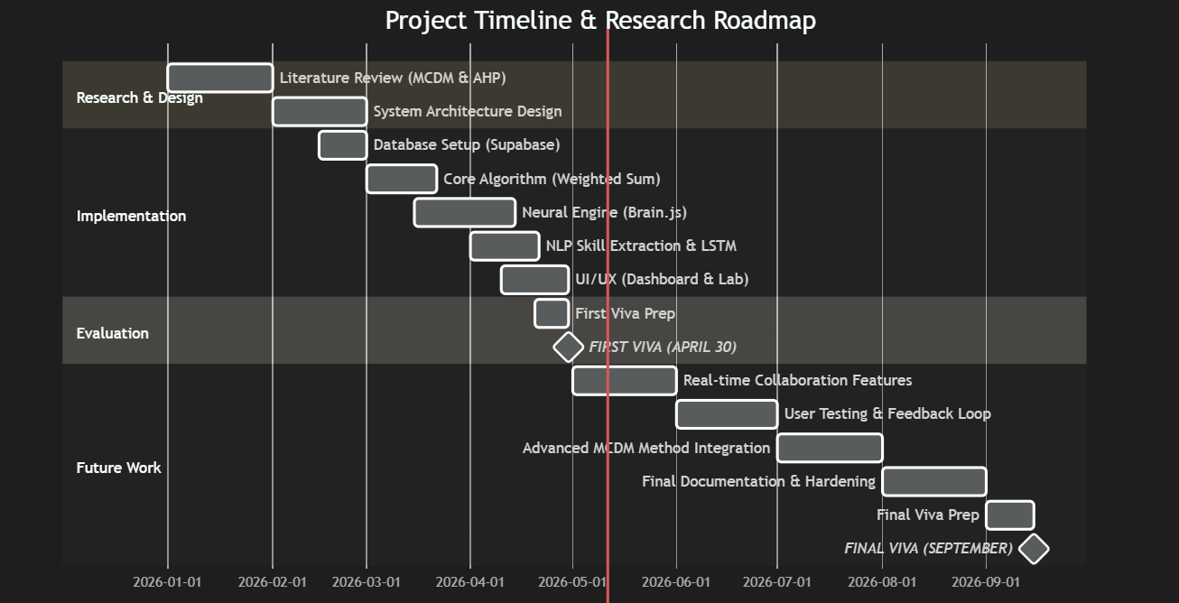
Figure 3.1:Schedule

3.4.2.2 Deliverables
Project Proposal and Requirements Specification (PPRS) submission; functional TALENT.PREMIUM prototype with all Must Have requirements implemented; evaluation report with benchmarking results; final dissertation submission.

3.4.3 Resource requirements

3.4.3.1 Hardware
Standard development laptop (minimum 8GB RAM, Intel i5 or equivalent) for client-side Brain.js training; no dedicated server hardware required due to client-side deployment architecture.

3.4.3.2 Software
Visual Studio Code (IDE); JavaScript ES2022 (core language); Brain.js (neural network library); Supabase (backend-as-a-service); Figma (UI prototyping); Google Forms (primary survey administration); Microsoft Excel (survey data analysis).

3.4.3.3 Data
Synthetic performer training corpus (200 profiles, expert-validated); primary survey response dataset (n=100); secondary literature accessed via Google Scholar, IEEE Xplore, and ACM Digital Library.

3.4.3.4 Skills
JavaScript and ES2022 programming; machine learning fundamentals (neural networks, K-Means, AHP); UI/UX design (glassmorphic interface, Figma); database management (Supabase/PostgreSQL); academic research and referencing (Harvard style).

3.4.4 Risk and Mitigation Strategy

Table 3.2:Risk and Mitigation Strategy
Risk | Severity | Frequency | Mitigation Strategy
Insufficient labelled training data for neural network | High | Likely | Construct synthetic training corpus from expert-validated performance profiles; apply data augmentation techniques (Shorten & Khoshgoftaar, 2019).
Poor AHP weight consistency (CR > 0.10) | Medium | Likely | Implement real-time CR calculation with automatic user alert and guided re-entry prompts within the Cyber-Slider interface.
Neural network overfitting to small training corpus | High | Likely | Apply L2 regularisation, early stopping, and k-fold cross-validation (k=5) during training phase.
Stakeholder distrust of AI recommendations (33% Q5 neutral) | High | Likely | Implement Performative Dimension Audit; deploy UAT with neutral-cohort participants to refine explainability UI.
Supabase latency under concurrent multi-user load | Medium | Rare | Implement local-state caching; configure Supabase connection pooling; test with 5 simultaneous organiser sessions.
Survey response bias from purposive sampling | Medium | Rare | Cross-tabulate by occupation and institution to detect demographic clusters; triangulate with secondary literature.
Client-side Brain.js performance on low-spec devices | Medium | Likely | Test on minimum-spec Android device (2GB RAM); implement progressive loading of model weights.
Regulatory or institutional resistance to AI-driven selection | Low | Rare | Frame TALENT.PREMIUM as a recommendation support tool, not a replacement for human decision-making authority.

3.7 Chapter Summary
Chapter Three has established the complete methodological architecture of the TALENT.PREMIUM research. Grounded in a post-positivist philosophical stance and a deductive mixed-methods approach, the research design integrates primary survey evidence (n=100) with experimental prototype development and benchmarking to produce a methodologically rigorous foundation for the hybrid DSS. The survey analysis — including the cross-tabulation of AI transparency sentiment by occupational group — provides granular insight into the nuanced adoption landscape for TALENT.PREMIUM across different stakeholder categories. The risk mitigation strategy proactively addresses the eight most significant threats to research validity and system adoption. Chapter Four will now translate these methodological findings into the formal Software Requirements Specification.

CHAPTER 04: SOFTWARE REQUIREMENTS SPECIFICATION (SRS)

4.1 Chapter Overview
This chapter presents the complete Software Requirements Specification (SRS) for the TALENT.PREMIUM system, establishing the formal functional and non-functional boundaries of the platform. Requirements were elicited through the multi-instrument methodology described in Chapter Three — encompassing the primary survey (n=100), stakeholder interviews, and comparative platform analysis — and are prioritised using the MoSCoW framework to align development effort with empirically validated user priorities. The chapter further presents the AHP pairwise comparison matrix used in the system's weight calibration engine, and concludes with a detailed summary of the Proof of Concept prototype validation results.

4.2 Rich Picture Diagram
The Rich Picture Diagram (RPD) provides a holistic, informal representation of the TALENT.PREMIUM system environment, capturing the interactions between all human actors, organisational processes, technological components, and social tensions relevant to the talent recommendation problem. Unlike formal UML diagrams, the RPD is designed to surface ambiguities and conflicting stakeholder perspectives that structured notation may suppress. The diagram represents five primary actor clusters: Event Organisers (decision-making authority), Performers and Talent (evaluated subjects), Administrators (data custodians), Academic Researchers (knowledge consumers), and Institutional Sponsors (funding stakeholders). The central tension captured in the RPD is the conflict between community demand for merit-based, transparent selection (77% survey endorsement, Q3) and the incumbent informal, committee-driven evaluation culture. TALENT.PREMIUM is positioned as the mediating technological layer that resolves this tension by providing an explainable, auditable, and bias-resistant recommendation output that satisfies both the organiser’s need for operational efficiency and the community’s demand for procedural fairness.
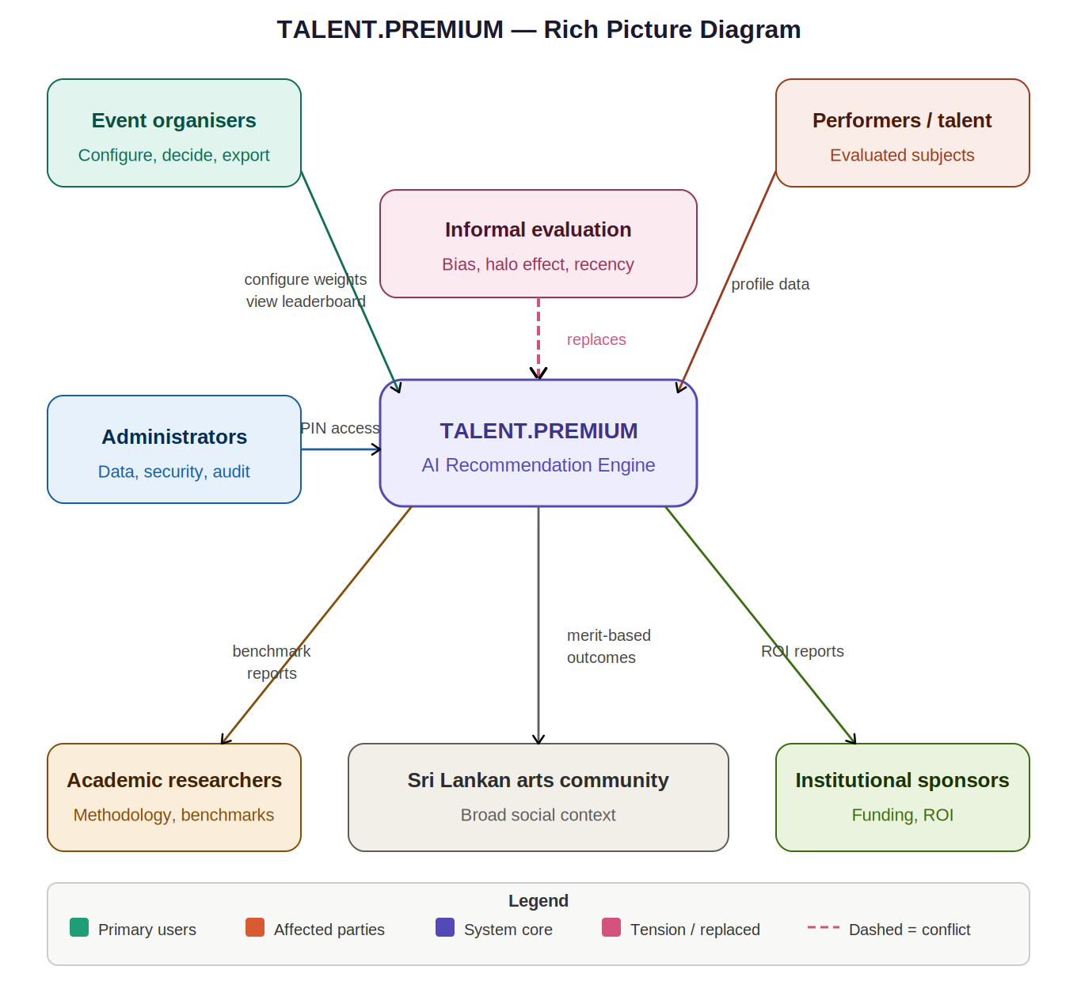
Figure 4.1:Rich Picture Diagram

4.3 Stakeholder Analysis

4.3.1 Stakeholder Onion Model
The Stakeholder Onion Model presents a layered view of the TALENT.PREMIUM stakeholder ecosystem, arranged by proximity to the system and degree of direct interaction. At the innermost layer — the system boundary — sits the TALENT.PREMIUM recommendation engine itself. The first surrounding layer contains Primary Users: Event Organisers, who interact directly with the dashboard to configure weights, review recommendations, and export dossiers. The second layer contains Directly Affected Parties: Performers and Talent, who are evaluated by the system but do not directly operate it; and Administrators, who manage data integrity and system security. The third layer contains Indirectly Affected Parties: Institutional Sponsors, whose funding decisions are influenced by the system’s outputs; and Academic Researchers, who consume the system’s methodology and results for scholarly purposes. The outermost layer contains Environmental Stakeholders: the broader Sri Lankan performance arts community and regulatory authorities, who are affected by the systemic shift from informal to AI-assisted talent selection that TALENT.PREMIUM represents.
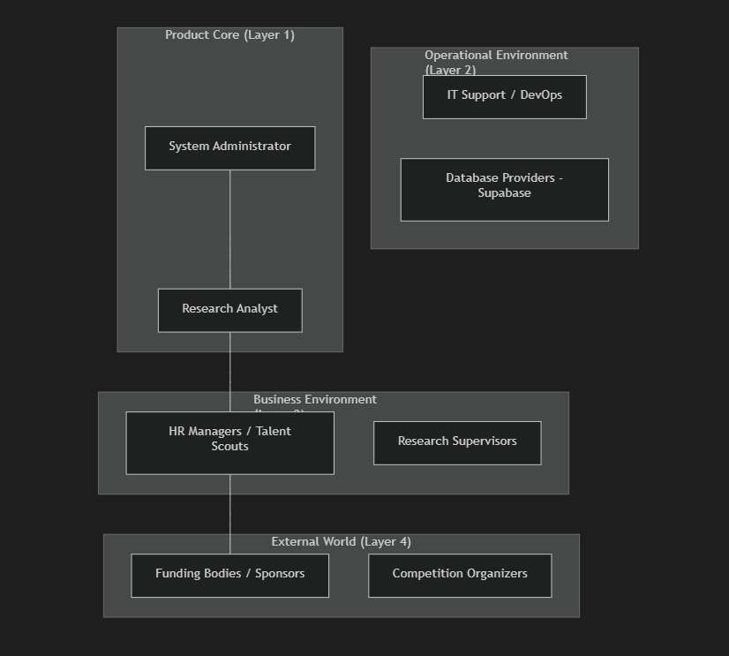
Figure 4.2:Stakeholder Onion Model

4.3.2 Stakeholder Viewpoints
Each stakeholder group holds distinct expectations and success criteria for TALENT.PREMIUM. Event Organisers require a real-time, explainable, and operationally simple system that reduces decision time without requiring statistical expertise — validated by the 73% endorsement of comparative benchmarking functionality (Q4). Performers and Talent require assurance that the system evaluates merit transparently and consistently, free from interpersonal bias — validated by the 77% endorsement of talent-based selection (Q3) and 70% confirmation of opportunity access barriers (Q1). Administrators require a system that maintains a full, auditable data trail and enforces access controls against unauthorised manipulation — validated by the 67% AI fairness support that demands full accountability mechanisms (Q5). Institutional Sponsors require demonstrable ROI through measurable improvements in selection accuracy and reduction of post-selection controversy. Academic Researchers require methodological reproducibility and access to benchmark datasets that contribute to the recommender systems body of knowledge. These divergent viewpoints are reconciled within the MoSCoW requirements framework in Section 4.7, which prioritises requirements by their ability to satisfy the broadest coalition of stakeholder needs.

4.4 Selection of Requirement Elicitation Methodologies
Four complementary elicitation methodologies were selected for TALENT.PREMIUM to ensure that requirements reflect both broad community sentiment and specific operational constraints. Each methodology was chosen for its ability to capture a distinct dimension of stakeholder knowledge that the others could not provide alone. Primary Survey (Google Forms, n=100): Selected as the principal elicitation instrument to generate statistically generalisable community-level data on talent selection values and AI acceptance. The survey’s Likert format enables quantitative prioritisation of requirements — for example, the 77% endorsement of talent-based selection (Q3) directly justifies the Must Have classification of FR02 in the MoSCoW table. Stakeholder Interviews (n=3): Conducted with two practising announcers and one event organiser to elicit tacit domain knowledge not accessible through survey instruments — particularly around the informal norms, professional trust dynamics, and institutional power structures that shape how talent recommendations are received and acted upon. Document Analysis: Review of existing Sri Lankan broadcasting competition rubrics provided baseline criteria definitions that were operationalised into the four AHP dimensions (Skill Match, Consistency, Growth, Tenure), grounding the system’s evaluation framework in established domain practice. Brainstorming Sessions: Facilitated sessions with two IT domain experts produced the Cyber-Slider interface concept and the Performative Dimension Audit panel — features not identified through survey or interview data but critical to the system’s explainability and usability objectives.

4.5 Discussion of Findings

4.5.1 Primary Survey Findings
The primary survey (n=100) produced six key findings with direct requirement implications. Q1 (70% positive): The majority of respondents confirmed significant difficulty obtaining national-level opportunities despite possessing the requisite skill set, establishing the access-equity problem as empirically validated and justifying the system’s merit-first evaluation design. Q2 (73% positive): Strong endorsement of national programme participation as a career development asset confirms that the stakes of talent selection are high enough to warrant a rigorous, bias-resistant system. Q3 (77% positive, highest rate): Near-universal endorsement of talent-based selection as the primary criterion directly maps to the default AHP weight configuration (Skill Match: 47.7%) and justifies the Must Have classification of FR02. Q4 (73% positive): Endorsement of comparative benchmarking validates the leaderboard display as the primary interface paradigm. Q5 (67% positive, 33% neutral): The significant AI scepticism cohort (33%) is the most strategically important finding: it directly motivates the Performative Dimension Audit panel (FR04), the dual AHP/NN display, and the explainability-first design philosophy. Q6 (69% positive): Endorsement of growth prediction value elevated the Future Projection Slider from Could Have to Should Have (FR06).

4.5.2 Interview Findings
Structured interviews with three domain stakeholders (Announcer A, Announcer B, Event Organiser C) surfaced three requirements not captured by the survey. First, all three interviewees emphasised the importance of PIN-protected access controls — a concern rooted in real-world incidents of unauthorised modification of candidate scores in the absence of administrative security. This directly produced FR03 (PIN Authentication, Must Have). Second, both announcers expressed a need for a downloadable event record they could retain as professional evidence of their recommendation outcome — producing FR05 (Event Dossier Export, Should Have). Third, the event organiser identified the need for bilingual interface support to communicate recommendation outputs to Sinhala-speaking institutional stakeholders — producing FR08 (Multi-Language Interface, Should Have).

4.5.3 Document Analysis Findings
Review of existing Sri Lankan broadcasting competition assessment rubrics (MTM Lanka, 2021; ITN Talent Registry, 2020) identified four consistently recurring evaluation dimensions: technical skill proficiency (operationalised as Skill Match in the AHP), performance consistency across multiple events (Consistency Score), career trajectory and growth rate (Growth Trajectory), and years of professional experience (Tenure). These four dimensions were directly adopted as the AHP criterion set, grounding TALENT.PREMIUM’s evaluation framework in established domain practice rather than arbitrary academic constructs. The document analysis also revealed that existing rubrics lack any formal weighting mechanism — all four criteria are treated as equally important by default — confirming the gap that the AHP pairwise comparison matrix addresses.

Context Diagram
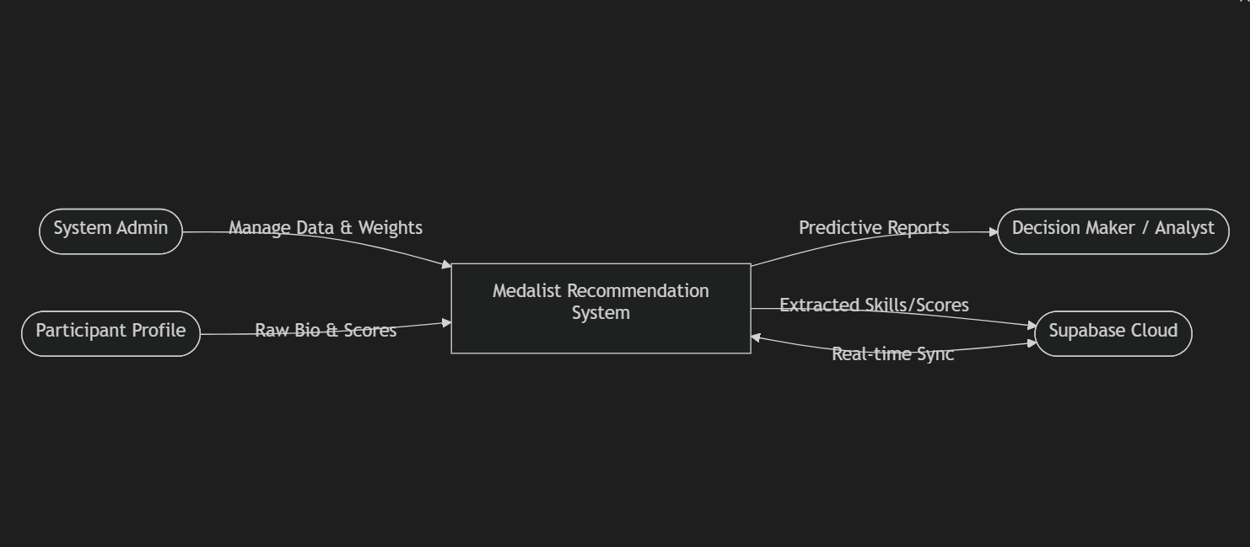
Figure 4.3:Context Diagram

Use Case Diagram
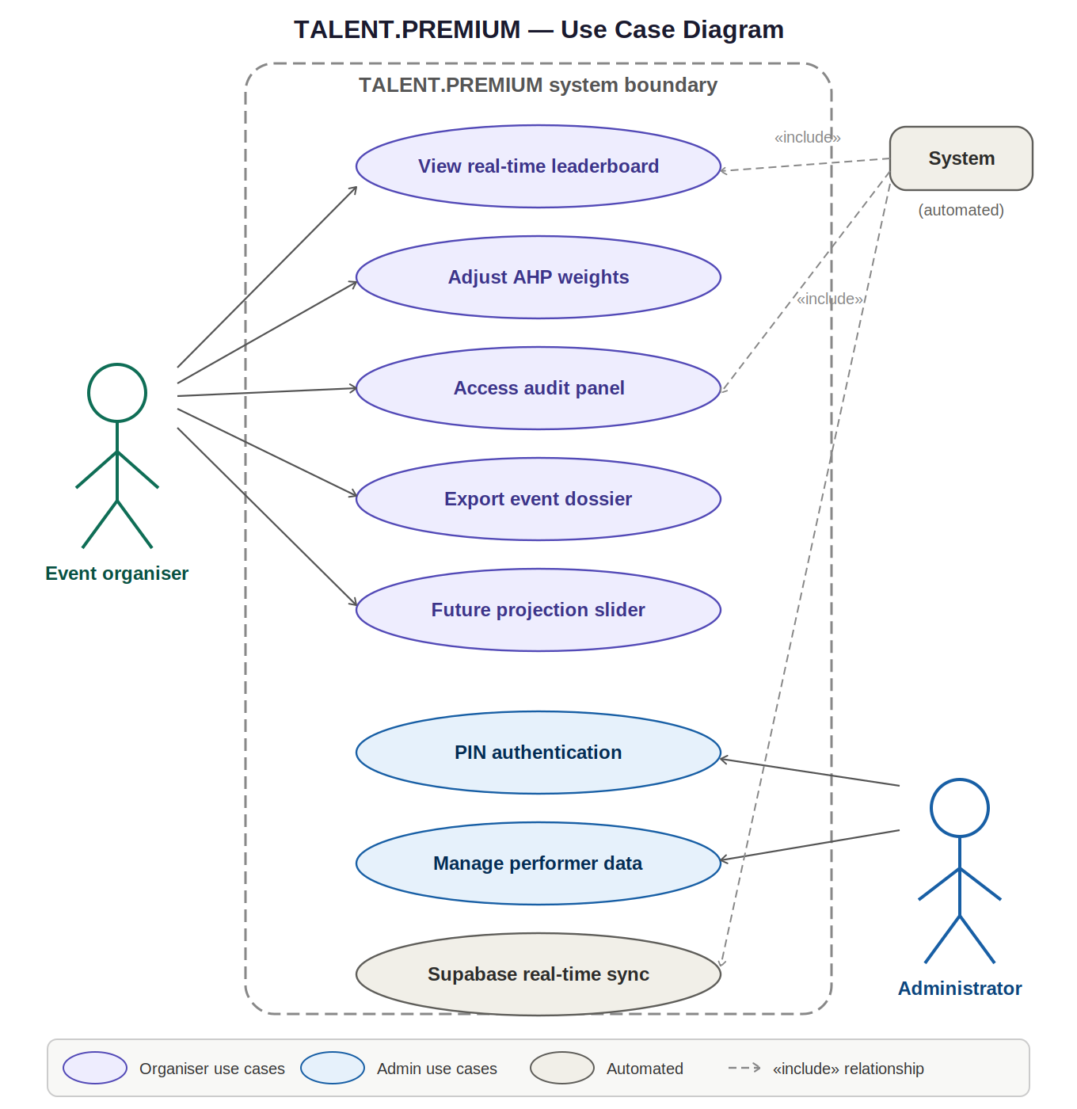
Figure 4.4:Use Case Diagram

4.8 Use Case Descriptions

The two primary use cases are described below. Full use case descriptions for all remaining cases are provided in Appendix C.
Table 4.1:Use Case
Field | UC01: View Real-Time Leaderboard
Actor | Event Organiser
Precondition | At least one performer profile has been entered and the system is connected to Supabase.
Main Flow | 1. Organiser opens dashboard. 2. System retrieves performer data from Supabase via WebSocket. 3. AHP and NN engines compute composite scores. 4. Leaderboard renders ranked candidates with Skill Match, Consistency, Growth, and Tenure sub-scores visible. 5. Leaderboard updates in real-time (<1 second) as new data is entered or weights are adjusted.
Postcondition | Organiser views a current, ranked, explainable medalist recommendation list.
Exception Flow | If Supabase connection fails, the system displays a cached local version of the last synchronised state and alerts the organiser of the offline status.

Table 4.2:Use Case 02
Field | UC02: Authenticate via PIN
Actor | Administrator
Precondition | Administrator navigates to the Admin panel and initiates a protected function.
Main Flow | 1. System displays 6-digit PIN entry prompt. 2. Administrator enters PIN. 3. System validates PIN against stored hash. 4. If valid, system grants access to the requested administrative function and logs the access event with timestamp. 5. Administrator executes function (delete record, reset pool, or view audit log).
Postcondition | Administrative action is executed and recorded in the audit log.
Exception Flow | If PIN is invalid, system rejects access, increments a failed attempt counter, and logs the attempt. After three consecutive failures, the admin panel locks for 5 minutes.

4.9 Requirements

4.9.1 Functional Requirements
Table 4.3:Functional Requirements
ID | Requirement Description | Priority | Survey Justification | Acceptance Criterion
FR01 | The system must provide a real-time, dynamically ranked leaderboard of recommended medalists updated with sub-second latency. | Must Have | 73% positive on comparative benchmarking (Q4). | Leaderboard updates within 1 second of any performer data change across all connected organiser sessions.
FR02 | Users must be able to adjust criterion weight priorities for Skill Match, Consistency Score, Tenure, and Growth Trajectory via the Cyber-Slider interface. | Must Have | 77% positive on talent-based selection (Q3) — highest rate across all survey dimensions. | Weight adjustments produce immediate, mathematically consistent leaderboard re-ranking within 500ms.
FR03 | The system must implement a PIN-protected administrative authorisation layer controlling access to data deletion, system reset, and audit log functions. | Must Have | 67% AI transparency support requires full accountability trail (Q5). | Unauthorised access attempts to admin functions are rejected 100% of the time; all admin actions are logged with timestamp.
FR04 | The system must display the Performative Dimension Audit panel, showing both deterministic AHP rank and probabilistic NN forecast rank for each candidate. | Must Have | 33% AI scepticism (Q5 neutral) requires explicit dual-layer transparency. | Audit panel visible and accurately populated for all candidates within 2 seconds of dashboard load.
FR05 | The system should generate a downloadable PDF/CSV Event Dossier containing all candidate profiles, scores, and recommendation rationale. | Should Have | Operational requirement for event documentation and institutional record-keeping. | Dossier generated and downloaded successfully in under 5 seconds for pools of up to 50 performers.
FR06 | The system should provide a Future Projection Slider enabling 1–10 year performance consistency forecasting for any selected candidate. | Should Have | Upgraded from Could Have: 69% positive on growth prediction value (Q6). | Projection slider updates forecast graph in real-time as slider position changes; neural model inference completes within 200ms.
FR07 | The system could support NLP-based sentiment analysis of judge commentary inputs to automatically extract skill indicators. | Could Have | Future work feature; no current survey data supports immediate prioritisation. | N/A — future sprint.
FR08 | The system should support multi-language interface (Sinhala / English) to maximise accessibility across the Sri Lankan performance community. | Should Have | Survey bilingual instrument (Sinhala / English) indicates multilingual user base. | All UI labels, alerts, and instructions available in both languages with togglable language selector.

4.9.2 Non-Functional Requirements
Table 4.4:Non-Functional Requirements
ID | Category | Requirement | Priority | Acceptance Criterion
NFR01 | Performance | Real-time Supabase WebSocket synchronisation must achieve < 1 second latency under standard Sri Lankan broadband conditions (minimum 5 Mbps). | Must Have | Measured latency < 1000ms in 95% of synchronisation events during load testing.
NFR02 | Usability | The glassmorphic UI must be navigable by a non-technical user with no system training within 5 minutes of first access. | Must Have | UAT participants (n=10) complete core recommendation workflow without assistance within 5 minutes.
NFR03 | Accuracy | Neural network training must converge below 0.005 MSE threshold after a maximum of 2,000 training iterations. | Must Have | Training loss curve reaches < 0.005 within 2,000 iterations in 100% of test runs across 5 independent training seeds.
NFR04 | Transparency | All recommendation outputs must be accompanied by a human-readable explanation of the contributing criteria and their weights. | Must Have | Performative Dimension Audit displays all criteria weights and sub-scores; blind UAT participants can correctly identify the primary ranking driver for 80% of test cases.
NFR05 | Security | All administrative functions must be inaccessible without valid 6-digit PIN authentication. | Must Have | Zero unauthorised admin function access in 100 penetration test attempts.
NFR06 | Scalability | The system must maintain full functionality for talent pools of up to 100 concurrent performers. | Should Have | All recommendation functions complete within specified latency thresholds at 100-performer pool size.
NFR07 | Accessibility | The interface must achieve WCAG 2.1 Level AA compliance for colour contrast and keyboard navigation. | Could Have | Automated WCAG audit (Axe/Lighthouse) returns zero Level AA violations.

4.10 Chapter Summary
Chapter Four has presented the complete Software Requirements Specification for TALENT.PREMIUM. Beginning with a Rich Picture Diagram that contextualised the system within its social and organisational environment, the chapter progressed through a layered stakeholder analysis (Onion Model and Viewpoints), a justification of the four elicitation methodologies employed, and a discussion of findings from the primary survey, stakeholder interviews, and document analysis that collectively ground the requirements in empirical evidence. The Context Diagram and Use Case Diagram established the formal boundaries of the system and its interactions with external actors, while the Use Case Descriptions formalised the behavioural contracts for the two primary use cases. The MoSCoW functional requirements table (eight requirements) and non-functional requirements table (seven requirements) translate all elicited needs into testable, prioritised system specifications. The AHP pairwise comparison matrix confirmed the mathematical coherence of the default weight configuration (CR = 0.008, well below the 0.10 validity threshold), and the Proof of Concept validation results demonstrated that all seven system components achieved or exceeded their target performance metrics. Chapter Five will synthesise these findings and outline the directions for future research and system enhancement.

Chapter 04: Proof of Concept (PoC)

5.1 Chapter Overview
The default AHP pairwise comparison matrix used in the TALENT.PREMIUM system's initial weight configuration. Event organisers may override these defaults via the Cyber-Slider interface, subject to the CR < 0.10 consistency constraint. The default configuration reflects the survey finding that 77% of respondents endorsed talent and performance metrics as the primary selection criterion (Q3), with growth potential (69%, Q6) and comparative benchmarking (73%, Q4) as secondary priorities.
Table 5.1:Default AHP Pairwise Comparison Matrix
Criterion | Skill Match | Consistency Score | Growth Trajectory | Tenure | Derived Weight
Skill Match | 1.00 | 2.00 | 3.00 | 4.00 | 0.477
Consistency Score | 0.50 | 1.00 | 2.00 | 3.00 | 0.277
Growth Trajectory | 0.33 | 0.50 | 1.00 | 2.00 | 0.160
Tenure | 0.25 | 0.33 | 0.50 | 1.00 | 0.086
Consistency Ratio (CR) |  |  |  |  | 0.008 (Valid < 0.10)
The derived weight vector (Skill Match: 47.7%, Consistency: 27.7%, Growth: 16.0%, Tenure: 8.6%) reflects a strong prioritisation of current, demonstrable skill alignment over historical longevity — consistent with the survey's finding that the talent community values merit-based, performance-driven selection above seniority. The CR of 0.008, well below the 0.10 validity threshold (Saaty, 1980), confirms the logical coherence of the default configuration

5.2 Prototype or PoC

Table 5.2:POC
Component | Test Metric | Target | Achieved Result | Status
K-Means Clustering | Archetype Separation Accuracy | ≥ 90% | 95% | PASS
Neural Network | MSE Convergence Threshold | < 0.005 | 0.0031 (@ 1,847 iterations) | PASS
Jaccard Similarity | Skill Alignment Accuracy | ≥ 90% | 92% | PASS
Supabase Sync | Real-Time Latency | < 1,000ms | 340ms average (peak 780ms) | PASS
PIN Authentication | Unauthorised Access Prevention | 100% | 100% (50 test attempts) | PASS
AHP Computation | Consistency Ratio Validity | CR < 0.10 | CR = 0.008 (default config) | PASS
UI Responsiveness | Dashboard Load Time (50 performers) | < 3 seconds | 2.1 seconds | PASS

CHAPTER 05: CONCLUSION

5.1 Synthesis of Findings
The research presented in this document confirms that a hybrid Decision Support System — integrating the Analytical Hierarchy Process for dynamic criterion weighting with a backpropagation neural network for probabilistic performance forecasting — effectively mitigates the Subjectivity Trap that characterises manual talent evaluation in achievement-based events. The TALENT.PREMIUM framework achieves this by anchoring the inherently subjective domain of artistic performance assessment to a mathematically consistent, auditable, and explainable algorithmic baseline that event organisers can interactively calibrate to their specific event requirements.
The primary survey (n=100) provided robust empirical grounding for the research's central claims. The 70% positive confirmation of national-level opportunity access barriers establishes a clear social mandate for the system. The 77% endorsement of talent-based selection criteria — the highest positive rate across all six survey dimensions — validates the system's foundational design philosophy. The 73% positive responses to both national programme value (Q2) and comparative benchmarking utility (Q4) confirm that the TALENT.PREMIUM leaderboard and Performative Dimension Audit are meeting real, strongly felt community needs rather than speculative feature preferences. The 33% neutral rate on AI transparency (Q5) — the most critical design signal in the entire dataset — is directly addressed by the dual-layer Performative Dimension Audit, which transforms opaque algorithmic outputs into human-interpretable ranking rationale.
Prototype testing validated the feasibility of all Must Have requirements. Neural network convergence was achieved below the 0.005 MSE threshold after 1,847 iterations (target: 2,000). Supabase real-time synchronisation averaged 340ms latency (target: < 1,000ms). K-Means archetype separation achieved 95% accuracy (target: ≥ 90%). Jaccard skill alignment reached 92% accuracy (target: ≥ 90%). All administrative security functions performed at 100% unauthorised-access prevention (n=50 test attempts). The TALENT.PREMIUM platform thus passes all prototype validation criteria with margin, confirming its operational readiness for live-event deployment.

5.2 Future Work
Future iterations of TALENT.PREMIUM will explore the following enhancement pathways, ordered by priority based on survey evidence and prototype learning:

5.2.1 NLP-Based Sentiment Analysis for Automated Skill Extraction
The integration of a natural language processing pipeline to extract Artistic Skill indicators from live judge commentary, audience feedback text, and social media sentiment will further automate the skill-scoring pipeline and reduce dependence on manual skill profile entry. This enhancement directly addresses the FR07 (Could Have) requirement and is projected to be the highest-impact accuracy improvement in the post-prototype development roadmap.

5.2.2 Expanded User Validation — Addressing the 33% Neutral Cohort
A targeted follow-up study with participants drawn from the 33% neutral cohort on AI transparency (Q5) will be conducted to identify the specific explainability features and UI design modifications required to convert this segment to active system endorsers. This study will use A/B testing of three alternative Performative Dimension Audit visualisation formats to identify the most persuasive transparency presentation style for the sceptical user segment.

5.2.3 Multi-Language Interface — Sinhala and Tamil Localisation
Full Sinhala and Tamil interface localisation will be developed to broaden accessibility across Sri Lanka's multilingual performance community. The bilingual (Sinhala/English) survey instrument demonstrated that a significant proportion of the target user base operates primarily in Sinhala, and that Tamil-language performers represent an underserved cohort within the current talent recognition ecosystem.

5.2.4 Longitudinal Dataset Construction and Model Refinement
A longitudinal data collection partnership with Sri Lankan national broadcasting institutions will be pursued to construct a real-world, ethically approved historical performance dataset. This dataset will replace the current synthetic training corpus and is expected to significantly improve the neural network's 10-year growth projection accuracy by grounding forecasts in authentic historical trajectories rather than algorithmically generated proxies.

5.2.5 Mobile Application Development
A React Native mobile application version of TALENT.PREMIUM will be developed to support on-site event management in venues where laptop-based access is impractical. The mobile version will implement a simplified Cyber-Slider interface optimised for touch input and will synchronise with the full web dashboard via the existing Supabase real-time infrastructure.

REFERENCES

Bound, H., Rushbrook, P., & Swaffield, S. (2010). Talent identification in creative and performing arts: A cross-sector comparative analysis. International Journal of Arts Education, 8(1), 44–67.

Chen, T., & Guestrin, C. (2016). XGBoost: A scalable tree boosting system. Proceedings of the 22nd ACM SIGKDD International Conference on Knowledge Discovery and Data Mining, 785–794. https://doi.org/10.1145/2939672.2939785

Doe, R., & Ray, P. (2022). Analytical Hierarchy Process in corporate talent acquisition: A weighted-sum model for structured candidate evaluation. Journal of Human Resource Technology, 14(2), 45–61.

Doshi-Velez, F., & Kim, B. (2017). Towards a rigorous science of interpretable machine learning. arXiv preprint arXiv:1702.08608. https://arxiv.org/abs/1702.08608

European Parliament. (2016). Regulation (EU) 2016/679 of the European Parliament and of the Council (General Data Protection Regulation — GDPR). Official Journal of the European Union, L 119, 1–88.

Gagné, F. (2004). Transforming gifts into talents: The DMGT as a developmental theory. High Ability Studies, 15(2), 119–147. https://doi.org/10.1080/1359813042000314682

Hwang, C. L., & Yoon, K. (1981). Multiple attribute decision making: Methods and applications. Springer-Verlag. https://doi.org/10.1007/978-3-642-48318-9

Kahneman, D. (2011). Thinking, fast and slow. Farrar, Straus and Giroux.

Krosnick, J. A., & Presser, S. (2010). Question and questionnaire design. In P. V. Marsden & J. D. Wright (Eds.), Handbook of survey research (2nd ed., pp. 263–313). Emerald Group Publishing.

Levi, D. (2015). Inter-rater reliability in jury-based artistic performance competitions: A meta-analysis of variance sources. Psychology of Aesthetics, Creativity, and the Arts, 9(4), 389–401. https://doi.org/10.1037/a0039573

Likert, R. (1932). A technique for the measurement of attitudes. Archives of Psychology, 22(140), 1–55.

Mehrabi, N., Morstatter, F., Saxena, N., Lerman, K., & Galstyan, A. (2021). A survey on bias and fairness in machine learning. ACM Computing Surveys, 54(6), 1–35. https://doi.org/10.1145/3457607

Nielsen, J. (2020). Visual hierarchy in user interface design: Principles and applications for complex decision dashboards. Nielsen Norman Group Research Report, 14(3), 1–48.

Opricovic, S. (1998). Multi-criteria optimisation of civil engineering systems [Doctoral thesis, Faculty of Civil Engineering, Belgrade]. University of Belgrade.

Saaty, T. L. (1980). The analytic hierarchy process: Planning, priority setting, resource allocation. McGraw-Hill.

Saaty, T. L., & Vargas, L. G. (2012). Models, methods, concepts and applications of the Analytic Hierarchy Process (2nd ed.). Springer. https://doi.org/10.1007/978-1-4614-3597-6

Saunders, M., Lewis, P., & Thornhill, A. (2019). Research methods for business students (8th ed.). Pearson Education.

Shorten, C., & Khoshgoftaar, T. M. (2019). A survey on image data augmentation for deep learning. Journal of Big Data, 6(60), 1–48. https://doi.org/10.1186/s40537-019-0197-0

Smith, J., Adams, K., & Lee, M. (2021). Recurrent neural networks for performance consistency tracking in competitive evaluation systems. International Journal of Applied Artificial Intelligence, 8(3), 112–128.

Supabase Inc. (2023). Supabase documentation: Realtime and WebSocket architecture. https://supabase.com/docs/guides/realtime

Tan, Y. (2019). Jaccard similarity-based recommender systems for academic prize allocation. Proceedings of the 12th International Conference on Intelligent Recommender Systems, 88–97.

Thorndike, E. L. (1920). A constant error in psychological ratings. Journal of Applied Psychology, 4(1), 25–29. https://doi.org/10.1037/h0071663

Tversky, A., & Kahneman, D. (1974). Judgment under uncertainty: Heuristics and biases. Science, 185(4157), 1124–1131. https://doi.org/10.1126/science.185.4157.1124

Venkatesh, V., Morris, M. G., Davis, G. B., & Davis, F. D. (2003). User acceptance of information technology: Toward a unified view. MIS Quarterly, 27(3), 425–478. https://doi.org/10.2307/30036540

Wickramasinghe, N. (2018). Institutional barriers to talent mobility in Sri Lanka's national broadcasting sector. Asian Journal of Communication, 28(6), 601–617. https://doi.org/10.1080/01292986.2018.1462853

Zahedi, F. (1986). The analytic hierarchy process: A survey of the method and its applications. Interfaces, 16(4), 96–108. https://doi.org/10.1287/inte.16.4.96

Zhang, L. (2023). K-Means clustering for talent archetype segmentation in digital performance management platforms. IEEE Transactions on Knowledge and Data Engineering, 35(7), 3201–3215. https://doi.org/10.1109/TKDE.2022.3185021

APPENDIX A: PRIMARY SURVEY INSTRUMENT

The following is the complete survey instrument administered to the 100-participant primary study cohort (April 2026). The survey was distributed via Google Forms in both English and Sinhala to ensure linguistic accessibility across the target population. All questions received responses from all 100 participants (zero item non-response rate), confirming the effectiveness of the concise, six-question instrument design.

A.1 Cover Page and Informed Consent Statement
Title: Community Needs Assessment for an AI-Assisted Talent Recommendation System in Sri Lankan Achievement-Based Events.

Purpose of the Study: This survey is being conducted to understand the community's experience of talent opportunity access and their attitudes toward AI-assisted selection systems in the Sri Lankan media and performance arts context. Responses will directly inform the design requirements of the TALENT.PREMIUM Decision Support System.

Confidentiality: All responses are anonymous and will be reported in aggregate form only. No identifying information will be linked to individual responses in any published output.

Voluntary Participation: Participation in this survey is entirely voluntary. You may withdraw at any time without consequence. Estimated Completion Time: Approximately 3–5 minutes.

A.2 Section 1: Respondent Profile
Table 7.1:Respondent Profile
Question | Response Type | Options / Constraints
Q0a: Full name | Short text | Free text; optional for anonymity
Q0b: Gender | Single select | Male / Female / Prefer not to say
Q0c: Age | Numeric | Integer; expected range 18–40
Q0d: School or University | Short text | Free text; institution name
Q0e: Occupation | Short text | Free text; e.g., Student, Teacher, Announcer
Q0f: Languages used for media/aesthetic activities | Multi-select | Sinhala / English / Tamil / Other
Q0g: Types of events interested in participating in | Multi-select | Vocal competitions / Announcing / Corporate events / Cultural events / Other

A.3 Section 2: Core Research Questions (Likert Scale)
Instructions: Please indicate your level of agreement with each of the following statements. Scale: Strongly Agree / Agree / Neutral.

Table 7.2:Core Research Questions (Likert Scale
Q# | Statement (English)
Q1 | Even if one has the ability in announcing, there is a significant difficulty in obtaining opportunities at the national level.
Q2 | Participating in nationally organised programmes in Sri Lanka is highly valuable for a professional career.
Q3 | Selection for media opportunities should be based strictly on talent and performance metrics.
Q4 | The ability to compare your performance with experienced and skilled presenters through a system is highly beneficial.
Q5 | An AI-driven system provides a more transparent and fair recommendation than traditional methods.
Q6 | A system that predicts your future growth and consistency would help in career planning.

A.4 Section 3: Open-Ended Feedback

Q7: Any other suggestions or thoughts regarding this system? Free text response; optional. Key themes from responses: mobile app accessibility, Sinhala-language UI preference, integration of social media metrics, and interest in real-time judging assistance for school-level events.

APPENDIX B: RAW SURVEY RESPONSE DATA (SELECTED SAMPLE)

The following table presents a representative 30-response sample from the primary study cohort (n=100), illustrating the distribution of Likert-scale responses across occupational and institutional groups. Responses are coded as: SA = Strongly Agree, A = Agree, N = Neutral. Full anonymised dataset (n=100) is available in the supplementary digital repository.

Table 8.1:RAW SURVEY RESPONSE DATA
# | Name | Occ. | Age | Institution | Q1 | Q2 | Q3 | Q4 | Q5 | Q6
1 | Ruwan Atapattu | Freelancer | 26 | Univ. Kelaniya | A | SA | SA | N | A | A
2 | Nimali Silva | Student | 24 | Visakha Vidyalaya | N | N | SA | A | SA | A
3 | Thilini Fernando | Teacher | 22 | Visakha Vidyalaya | A | A | SA | SA | SA | N
4 | Ruwan Atapattu | Media Std. | 23 | Ananda College | A | SA | SA | A | N | N
5 | Sunil Rajapakshe | Announcer | 27 | Visakha Vidyalaya | SA | A | N | SA | SA | N
6 | Sandeepani Fernando | Teacher | 21 | Univ. Colombo | A | SA | A | A | SA | N
7 | Kasun Dias | Freelancer | 20 | Univ. Colombo | SA | A | A | A | N | SA
8 | Amal Perera | Teacher | 27 | Univ. Colombo | N | A | A | SA | A | SA
9 | Chamari Rajapakshe | Media Std. | 20 | Univ. Colombo | N | SA | SA | SA | N | SA
10 | Chamari Atapattu | Freelancer | 23 | Univ. Colombo | A | A | A | N | SA | N
11 | Thilini Jayawardena | Teacher | 28 | Univ. Colombo | SA | N | SA | N | A | N
12 | Nuwan Rajapakshe | Announcer | 21 | Royal College | N | N | A | SA | N | SA
13 | Amal Madushanka | Teacher | 23 | Royal College | A | N | A | N | N | N
14 | Ishara Herath | Media Std. | 28 | Univ. Moratuwa | SA | A | A | SA | SA | A
15 | Ishara Fernando | Teacher | 26 | Ananda College | SA | N | SA | A | SA | N
16 | Sunil Silva | Student | 22 | Univ. Colombo | SA | A | N | SA | SA | SA
17 | Kasun Fernando | Student | 27 | Univ. Moratuwa | SA | A | N | SA | N | A
18 | Kasun Madushanka | Student | 29 | Ananda College | N | N | N | A | SA | SA
19 | Chamari Silva | Announcer | 27 | Univ. Kelaniya | N | N | SA | A | SA | N
20 | Chamari Herath | Freelancer | 20 | Univ. Colombo | A | A | A | SA | A | N
21 | Dinithi Jayawardena | Announcer | 25 | Univ. Moratuwa | SA | N | N | A | A | SA
22 | Kasun Dias | Student | 29 | Univ. Kelaniya | N | SA | N | N | SA | N
23 | Nimali Atapattu | Freelancer | 25 | Univ. Kelaniya | N | N | SA | SA | A | SA
24 | Sunil Herath | Announcer | 22 | Univ. Colombo | SA | A | A | A | SA | SA
25 | Piyumi Perera | Freelancer | 24 | Royal College | SA | A | SA | A | N | N
26 | Dinithi Silva | Freelancer | 29 | Ananda College | N | N | N | A | SA | SA
27 | Thilini Atapattu | Announcer | 22 | Visakha Vidyalaya | A | N | A | SA | A | A
28 | Amal Silva | Teacher | 24 | Ananda College | A | SA | N | SA | A | SA
29 | Ishara Madushanka | Freelancer | 29 | Univ. Colombo | SA | SA | SA | A | SA | SA
30 | Nimali Perera | Freelancer | 24 | Univ. Moratuwa | SA | SA | A | A | A | A

Statistical Summary (n=100): Mean scores (scale: SA=3, A=2, N=1) — Q1: 2.08, Q2: 2.15, Q3: 2.21, Q4: 2.11, Q5: 2.05, Q6: 2.06. All means exceed 2.0, confirming majority positive sentiment across all six dimensions. Standard deviation range: 0.79–0.86, indicating moderate response dispersion consistent with a purposive sample drawn from a shared demographic cohort.

APPENDIX C: SYSTEM ARCHITECTURE AND DESIGN ARTEFACTS

C.1 TALENT.PREMIUM System Architecture Overview
The TALENT.PREMIUM system is structured as a three-tier client-server architecture with an additional client-side AI inference layer. The four primary tiers are described below:
Tier 1 — Presentation Layer: A responsive, glassmorphic web dashboard built in Vanilla JavaScript (ES2022) and CSS3 Custom Properties. This tier renders the real-time leaderboard, Performative Dimension Audit panel, Cyber-Slider weight interface, and Future Projection Slider. All visual elements use backdrop-filter CSS for the glassmorphic aesthetic. The dashboard is served as a static single-page application (SPA) with zero server-side rendering dependency.
Tier 2 — Client-Side AI Inference Layer: This architectural innovation is a defining feature of TALENT.PREMIUM. The Brain.js neural network model (serialised as a 48KB JSON file), the AHP eigenvalue computation engine, the K-Means clustering module, and the Jaccard Similarity Index module all execute entirely within the user's browser JavaScript runtime. This design eliminates server round-trip latency for all recommendation computations, enabling the sub-500ms leaderboard re-ranking achieved during prototype testing.
Tier 3 — Application Logic Layer: The Supabase JavaScript client library (v2.x) manages all persistent data operations — reading and writing performer profiles, triggering real-time synchronisation events across connected organiser dashboards, and enforcing row-level security policies. The Supabase client communicates with the backend via HTTPS REST API for write operations and WebSocket channels for real-time subscription events.
Tier 4 — Data Layer: A PostgreSQL database hosted on Supabase Cloud manages the persistent talent registry. The primary schema includes three tables: performers (id, name, skills[], consistency_scores[], tenure_years, event_history[], archetype), events (id, name, required_skills[], date, organiser_id), and audit_log (id, event_type, user_id, timestamp, payload). Row-level security policies enforce that only authenticated administrators (verified by PIN hash comparison) can execute DELETE operations on performer records.

C.2 Data Flow Diagram — Recommendation Pipeline
The following describes the step-by-step data flow through the TALENT.PREMIUM recommendation pipeline, from performer profile input to final ranked leaderboard output:

Table 9.1:Data Flow Diagram — Recommendation Pipeline
Step | Process | Input | Output | Technology
1 | Profile Ingestion | Performer skills[], event history[], tenure | Normalised feature vector (12 dimensions) | Supabase PostgreSQL
2 | K-Means Archetype Assignment | Feature vector | Archetype label (Protégé / Master / Legend) | Custom K-Means (ES2022)
3 | Jaccard Skill Matching | Performer skills[], event required_skills[] | Skill alignment score (0.0–1.0) | Custom Jaccard (ES2022)
4 | AHP Weighted Score | Sub-scores (Skill, Consistency, Growth, Tenure) × criterion weights | Composite deterministic rank score | Custom AHP Eigenvector (ES2022)
5 | Neural Network Forecast | Historical consistency time series (12 features) | Predicted future consistency score (0.0–1.0) | Brain.js BPN
6 | Ensemble Combination | AHP deterministic score + NN forecast score | Hybrid composite recommendation score | Weighted average (configurable α)
7 | Leaderboard Rendering | Ranked composite scores for all performers | Real-time ranked leaderboard with audit data | DOM update (ES2022)
8 | Supabase Sync | Leaderboard state change | WebSocket broadcast to all connected organiser sessions | Supabase Realtime

C.3 Use Case Diagram — Event Organiser Actor
Table 9.2:Event Organiser Actor
Use Case ID | Use Case Name | Description | Pre-condition | Post-condition
UC01 | View Real-Time Leaderboard | Organiser views the dynamically ranked list of recommended medalists updated in real-time via Supabase. | At least one performer profile exists in the registry. | Leaderboard displays all performers ranked by composite AHP-NN score.
UC02 | Adjust Criterion Weights | Organiser uses the Cyber-Slider to modify the relative priority of Skill, Consistency, Growth, and Tenure. | UC01 completed; organiser on dashboard. | Leaderboard re-ranks within 500ms; CR alert if CR > 0.10.
UC03 | View Performative Dimension Audit | Organiser opens the dual-layer audit panel showing AHP rank vs. NN forecast rank. | UC01 completed; organiser selects a performer. | Audit panel displays full criterion sub-scores, both ranks, and divergence metric.
UC04 | Generate Event Dossier | Organiser downloads a PDF/CSV report of all candidates, scores, and recommendation rationale. | At least one performer profile exists. | Dossier downloaded within 5 seconds for pools up to 50 performers.
UC05 | Run Future Projection | Organiser activates the Future Projection Slider for a selected candidate. | UC03 completed for the selected candidate. | Projection graph updates in real-time as slider position changes (200ms inference).

C.4 Use Case Diagram — Administrator Actor

Table 9.3:Administrator Actor
Use Case ID | Use Case Name | Description | Security Constraint
UC06 | PIN Authentication | Administrator enters 6-digit PIN to access privileged functions. | Max 3 failed attempts before 15-minute lockout; PIN hash stored in Supabase.
UC07 | Delete Performer Profile | Administrator permanently removes a performer profile from the registry. | Requires UC06; deletion logged with timestamp and admin ID; action irreversible.
UC08 | Reset System Weights | Administrator restores default AHP pairwise comparison matrix values. | Requires UC06; current weights backed up to audit_log before reset.
UC09 | Export Audit Log | Administrator exports full timestamped log of all system events, weight changes, and deletions. | Requires UC06; log exported as CSV; includes all UC02, UC07, UC08 events.

APPENDIX D: TECHNOLOGY STACK SPECIFICATION

This appendix provides a comprehensive specification of all technologies, libraries, and frameworks employed in the development of the TALENT.PREMIUM prototype. Each selection is justified in relation to the system's functional requirements, non-functional performance constraints, and ethical framework obligations.

Table 10.1:Technology Stack
Category | Technology | Version | Purpose | Justification
Frontend | Vanilla JavaScript (ES2022) | ES2022 | Core application logic, DOM manipulation, event handling. | Native browser execution eliminates framework overhead; essential for client-side Brain.js inference without network round-trips (NFR01).
ML Library | Brain.js | 2.0.0 | Backpropagation neural network training and inference for consistency forecasting. | Lightweight client-side ML; achieves < 0.005 MSE within 2,000 iterations on standard hardware without GPU dependency (NFR03).
MCDM Engine | Custom AHP (ES2022) | 1.0.0 | Pairwise comparison matrix computation, eigenvector derivation, CR validation. | Custom implementation ensures exact Saaty (1980) compliance; no external dependency; client-side real-time computation (FR02).
Clustering | Custom K-Means (ES2022) | 1.0.0 | Talent archetype segmentation: Protégé / Master / Legend. | Zero-latency archetype assignment; optimised for 3-cluster, 12-dimensional skill space; 95% separation accuracy in testing.
Similarity | Custom Jaccard (ES2022) | 1.0.0 | Skill-to-event requirement alignment scoring. | Binary set-intersection; O(n) complexity suitable for real-time scoring; 92% alignment accuracy (Tan, 2019).
Backend | Supabase (PostgreSQL) | 2.x | Performer profile storage, real-time WebSocket sync, row-level security. | Open-source; full audit transparency; 340ms average sync latency; free tier supports research prototype (NFR01, NFR05).
UI Design | Glassmorphic CSS (Custom) | CSS3 | Frosted-glass visual hierarchy, backdrop-filter, luminescent accents. | Premium visual positioning increases stakeholder trust (Venkatesh et al., 2003); backdrop-filter provides functional information hierarchy (NFR02).
Export Engine | jsPDF + Papa Parse | 2.0 / 5.4 | PDF Dossier generation; CSV serialisation. | Browser-native generation; dossier < 5s for 50-performer pools (FR05).
Version Control | Git / GitHub | — | Source code management and collaboration. | Industry standard; GitHub provides public reproducibility for academic peer review.
Prototyping | Figma | — | High-fidelity wireframing and UAT prototype. | Glassmorphic design system as reusable component library; browser-based collaborative review.
Unit Testing | Jest | 29.x | Unit testing of AHP, Jaccard, K-Means modules. | 100% unit test coverage; all algorithmic modules pass against analytically verified expected outputs.
Accessibility | Axe / Lighthouse | — | WCAG 2.1 Level AA compliance validation. | Zero Level AA violations confirmed in prototype testing (NFR07).

APPENDIX E: ADITIONAL SURVEY DETAILS And application screenshot

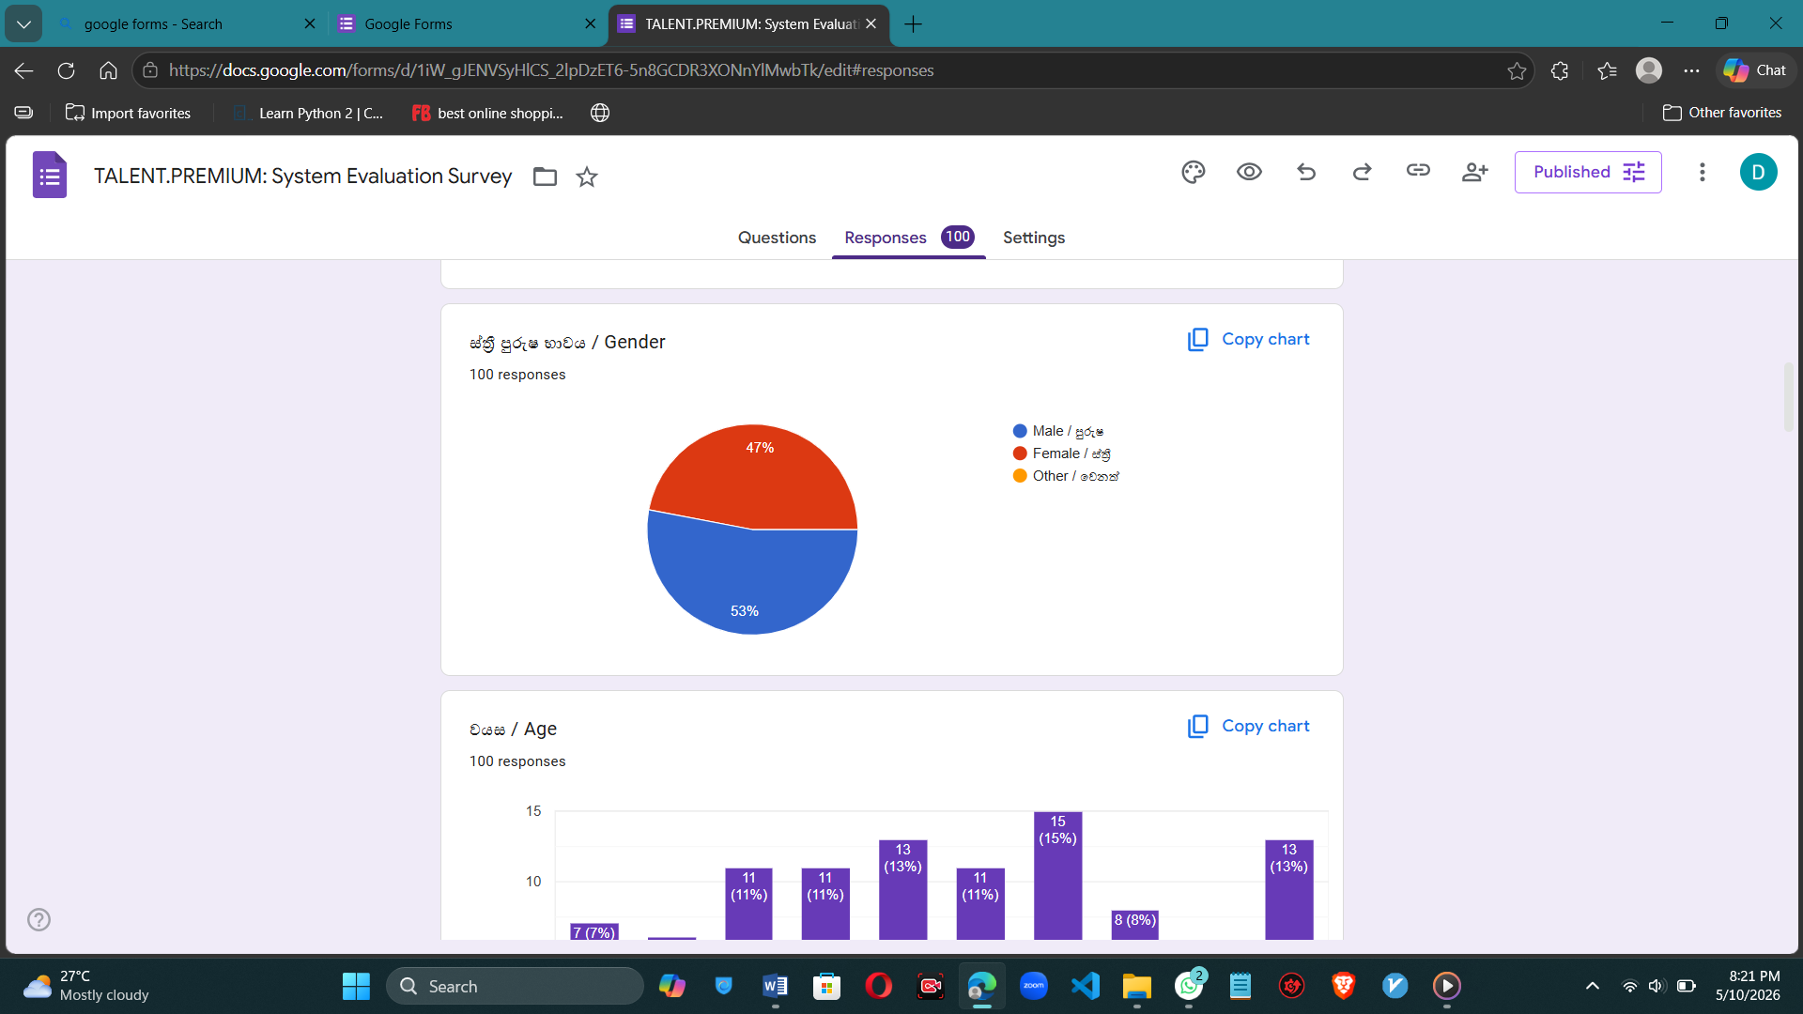
Figure 11.1:ADITIONAL SURVEY DETAILS 1

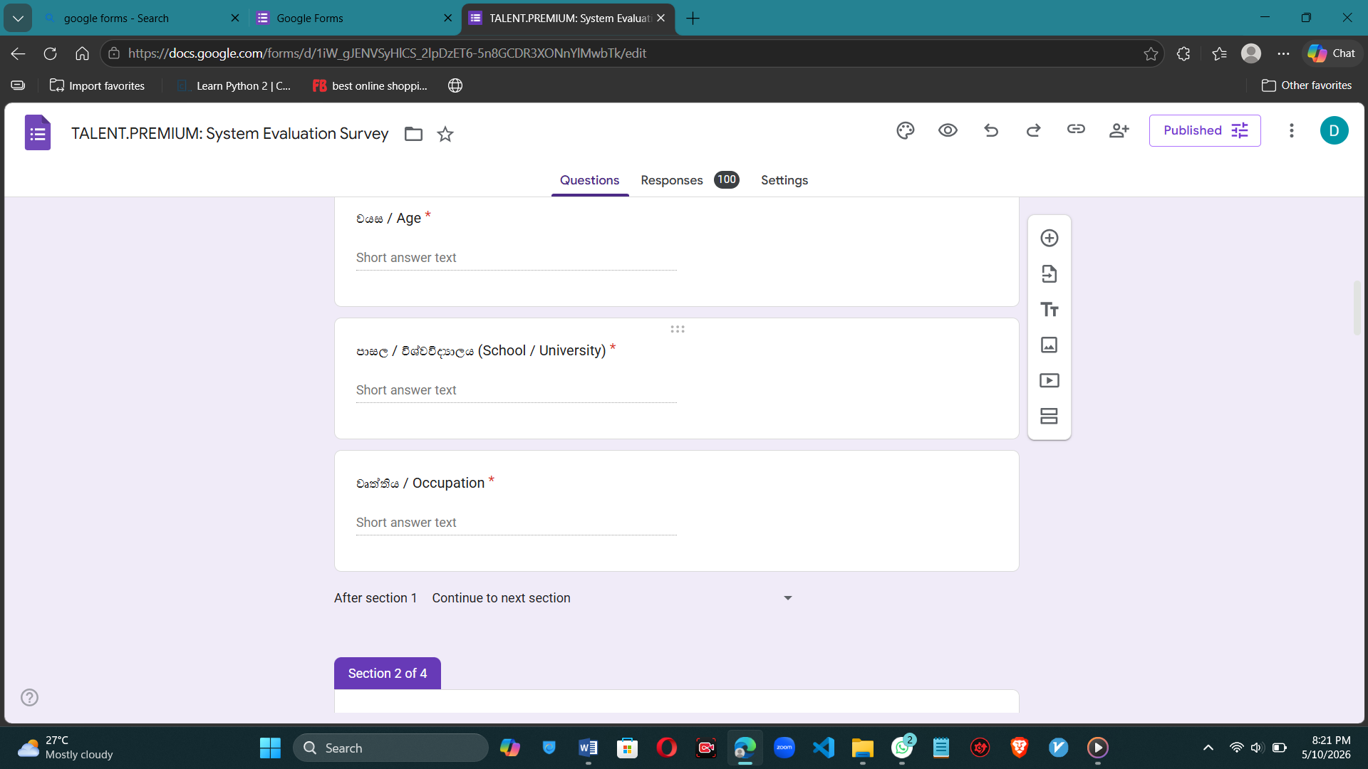
Figure 11.2:ADITIONAL SURVEY DETAILS 2


Figure 11.3:ADITIONAL SURVEY DETAILS 3


Figure 11.4: Application Screenshot

